**98-367.examcollection. premium. exam.123q**

**Exam code: 98-367**

**Exam name: Security fundamentals**

**Version 17.0**

**98-367**

**QUESTION 1**

Windows Firewall is a built-in. host-based, stateless firewall.

Select the correct answer if the underlined text does not make the statement correct. Select "No change is needed" if the underlined text makes the statement correct.

Stateful

Network layer

Packet filter

No change is needed

**Correct Answer:** A

**Section: (none) Explanation**

**Explanation/Reference:**

**QUESTION 2**

Bridging is a process of sending packets from source to destination on OSI layer 3.

Select the correct answer if the underlined text does not make the statement correct. Select "No change is needed" if the underlined text makes the statement correct.

Routing

Switching

Repeating

No change is needed.

**Correct Answer:** A

**Section: (none) Explanation**

**Explanation/Reference:**

**QUESTION 3**

The primary purpose of Network Access Protection (NAP) is to prevent:

Loss of data from client computers on a network.

Non-compliant systems from connecting to a network.

Users on a network from installing software.

Unauthorized users from accessing a network.

**Correct Answer:** B

**Section: (none) Explanation**

**Explanation/Reference:**

Explanation:

NAP enforces health policies by inspecting and assessing the health of client computers, restricting network access when client computers are noncompliant with health policy, and remediating noncompliant client computers to bring them into compliance with health policy before they are granted full network access. NAP enforces health policies on client computers that are attempting to connect to a network; NAP also provides ongoing health compliance enforcement while a client computer is connected to a network. Reference: http://technet.microsoft.com/en-us/library/cc754378(v=ws.10).aspx

**QUESTION 4**

You want to make your computer resistant to online hackers and malicious software.

What should you do?

Configure a forward proxy.

Install anti-virus software.

Enable spam filtering.

Turn on Windows Firewall.

**Correct Answer:** B

**Section: (none) Explanation**

**Explanation/Reference:**

**QUESTION 5**

Your company requires that users type a series of characters to access the wireless network.

The series of characters must meet the following requirements:

 Contains more than 15 characters

 Contains at least one letter

 Contains at least one number  Contains at least one symbol

Which security technology meets these requirements?

WEP

WPA2 PSK

WPA2 Enterprise

MAC filtering

**Correct Answer:** B

**Section: (none) Explanation**

**Explanation/Reference:**

Explanation: Pre-shared key mode (PSK, also known as Personal mode) is designed for home and small office networks that don't require the complexity of an 802.1X authentication server. [9] Each wireless network device encrypts the network traffic using a 256 bit key. This key may be entered either as a string of 64 hexadecimal digits, or as a passphrase of 8 to 63 printable ASCII characters

**QUESTION 6**

Many Internet sites that you visit require a user name and password. How should you secure these passwords?

Save them to a text file

Enable session caching

Configure the browser to save passwords

Save them to an encrypted file

Reuse the same password

**Correct Answer:** D

**Section: (none) Explanation**

**Explanation/Reference:**

**QUESTION 7**

Physically securing servers prevents:

Theft

Compromise of the certificate chain

Man-in-the middle attacks

Denial of Service attacks

**Correct Answer:** A

**Section: (none) Explanation**

**Explanation/Reference:**

**QUESTION 8**

To prevent users from copying data to removable media, you should:

Lock the computer cases

Apply a group policy

Disable copy and paste

Store media in a locked room

**Correct Answer:** B

**Section: (none) Explanation**

**Explanation/Reference:**

Reference: http://blogs.technet.com/b/askds/archive/2008/08/25/removable-storage-group- policy-andwindows-server-2008-and-windows-vista.aspx

**QUESTION 9**

You are an intern at Wide World Importers and help manage 1000 workstations. All the workstations are members of an Active Domain.

You need to push out an internal certificate to Internet Explorer on all workstations.

What is the quickest method to do this?

Local policy

Logon script

Windows Update

Group policy

**Correct Answer:** A

**Section: (none) Explanation**

**Explanation/Reference:**

**QUESTION 10**

In Internet Explorer 8, the InPrivate Browsing feature prevents:

Unauthorized private data input.

Unencrypted communication between the client computer and the server.

User credentials from being sent over the Internet.

Any session data from being stored on the computer.

**Correct Answer:** D

**Section: (none)**

**Explanation**

**Explanation/Reference:**

Reference: http://windows.microsoft.com/en-us/windows/what-is-inprivate-browsing

**QUESTION 11**

The purpose of a digital certificate is to verify that a:

Public key belongs to a sender.

Computer is virus-free.

Private key belongs to a sender.

Digital document is complete.

**Correct Answer:** A

**Section: (none) Explanation**

**Explanation/Reference:**

Explanation:

In cryptography, a public key certificate (also known as a digital certificate or identity certificate) is an electronic document that uses a digital signature to bind a public key with an identity.

**QUESTION 12**

A mail system administrator scans for viruses in incoming emails to increase the speed of mail processing.

Select the correct answer if the underlined text does not make the statement correct. Select "No change is needed" if the underlined text makes the statement correct.

Decrease the chances of a virus getting to a client machine

Verify that the senders of the messages are legitimate

Ensure that all links in the messages are trustworthy

No change is needed.

**Correct Answer:** A

**Section: (none) Explanation**

**Explanation/Reference:**

**QUESTION 13**

You are volunteering at an organization that gets a brand new web server. To make the server more secure, you should add a second administrator account.

Select the correct answer if the underlined text does not make the statement correct. Select "No change is needed" if the underlined text makes the statement correct.

Disable unused services

Enable LM authentication. Enable NTLM authentication

D. No change is needed.

**Correct Answer:** A

**Section: (none) Explanation**

**Explanation/Reference:**

**QUESTION 14**

Role separation improves server security by:

Enforcing principle of least privilege.

Installing applications on separate hard disks.

Physically separating high security servers from other servers.

Placing servers on separate VLANs.

**Correct Answer:** A

**Section: (none) Explanation**

**Explanation/Reference:**

**QUESTION 15**

The Windows Firewall protects computers from unauthorized network connections.

Select the correct answer if the underlined text does not make the statement correct. Select "No change is needed'' if the underlined text makes the statement correct.

Email viruses

Phishing scams

Unencrypted network access

No change is needed

**Correct Answer:** D

**Section: (none) Explanation**

**Explanation/Reference:**

**QUESTION 16**

Coho Winery wants to increase their web presence and hires you to set up a new web server. Coho already has servers for their business and would like to avoid purchasing a new one.

Which server is best to use as a web server, considering the security and performance concerns?

SQL Server

File Server

Domain Controller

Application Server

**Correct Answer:** C

**Section: (none) Explanation**

**Explanation/Reference:**

**QUESTION 17**

A user who receives a large number of emails selling prescription medicine is probably receiving pharming mail.

Select the correct answer if the underlined text does not make the statement correct. Select "No change is needed" if the underlined text makes the statement correct.

Malware

Spoofed mail

Spam

No change is needed.

**Correct Answer:** C

**Section: (none) Explanation**

**Explanation/Reference:**

**QUESTION 18**

The client computers on your network are stable and do not need any new features.

Which is a benefit of applying operating system updates to these clients?

Keep the software licensed

Keep the server ports available

Update the hardware firewall

Close existing vulnerabilities

**Correct Answer:** D

**Section: (none) Explanation**

**Explanation/Reference:**

**QUESTION 19**

Which password attack uses all possible alpha numeric combinations?

Social engineering

Brute force attack

Dictionary attack

Rainbow table attack

**Correct Answer:** C

**Section: (none) Explanation**

**Explanation/Reference:**

**QUESTION 20**

A digitally signed e-mail message:

Validates the recipient

Validates the sender

Is encrypted

Is virus-free

**Correct Answer:** B

**Section: (none) Explanation**

**Explanation/Reference:**

Explanation:

By digitally signing a message, you apply your unique digital mark to the message. The digital signature includes your certificate and public key. This information proves to the recipient that you signed the contents of the message and not an imposter, and that the contents have not been altered in transit.

Reference: http://office.microsoft.com/en-us/outlook-help/secure-messages-with-a-digital- signatureHP001230539.aspx

**QUESTION 21**

Passwords that contain recognizable words are vulnerable to a:

Denial of Service attack

Hashing attack

Dictionary attack

Replay attack

**Correct Answer:** C

**Section: (none) Explanation**

**Explanation/Reference:**

Explanation:

A dictionary attack is a method of breaking into a password-protected computer or server by systematically entering every word in a dictionary as a password. A dictionary attack can also be used in an attempt to find the key necessary to decrypt an encrypted message or document.

Dictionary attacks work because many computer users and businesses insist on using ordinary words as passwords. Dictionary attacks are rarely successful against systems that employ multiple-word phrases, and unsuccessful against systems that employ random combinations of uppercase and lowercase letters mixed up with numerals. Reference: http://searchsecurity.techtarget.com/definition/dictionary-attack

**QUESTION 22**

Account lockout policies are used to prevent which type of security attack?

Brute force attacks

Users sharing passwords

Social engineering

Passwords being reused immediately

**Correct Answer:** A

**Section: (none) Explanation**

**Explanation/Reference:**

**QUESTION 23**

What is the standard or basic collection of NTFS permissions?

Read and execute, read, write, full control, modify, list folder contents

Change permissions, read permissions, write permissions

Read attributes, list folder/read data, traverse folder/execute file

Create files/write data, create folders/append data, take ownership

**Correct Answer:** A

**Section: (none) Explanation**

**Explanation/Reference:**

Reference: http://technet.microsoft.com/en-us/library/bb727008.aspx

**QUESTION 24**

Which is the minimum requirement to create BitLocker-To-Go media on a client computer?

Windows XP Professional Service Pack 3

Windows Vista Enterprise Edition

Windows 7 Enterprise Edition

Windows 2000 Professional Service Pack 4

**Correct Answer:** A

**Section: (none) Explanation**

**Explanation/Reference:**

**QUESTION 25**

Which enables you to change the permissions on a folder?

Take ownership

Extended attributes

Auditing

Modify

**Correct Answer:** D

**Section: (none) Explanation**

**Explanation/Reference:**

**QUESTION 26**

A group of users has access to Folder A and all of its contents. You need to prevent some of the users from accessing a subfolder inside Folder A.

What should you do first?

Disable folder sharing

Hide the folder

Change the owner

Block inheritance

**Correct Answer:** A

**Section: (none) Explanation**

**Explanation/Reference:**

**QUESTION 27**

What are three examples of two-factor authentication? (Choose three.)

A fingerprint and a pattern

A password and a smart card

A username and a password

A password and a pin number

A pin number and a debit card

**Correct Answer:** ABE

**Section: (none) Explanation**

**Explanation/Reference:**

Explanation:

At minimum two-factor authentication requires two out of three regulatory-approved authentication variables such as:

 Something you know (like the PIN on your bank card or email password).

 Something you have (the physical bank card or a authenticator token).  Something you are (biometrics like your finger print or iris pattern).

**QUESTION 28**

You need to limit the programs that can run on client computers to a specific list. Which technology should you implement?

Windows Security Center

Security Accounts Manager

System Configuration Utility

AppLocker group policies

**Correct Answer:** A

**Section: (none) Explanation**

**Explanation/Reference:**

**QUESTION 29**

The purpose of User Account Control (UAC) is to:

Encrypt the user's account

Limit the privileges of software

Secure your data from corruption

Facilitate Internet filtering

**Correct Answer:** B

**Section: (none) Explanation**

**Explanation/Reference:**

Explanation:

User Account Control (UAC) is a technology and security infrastructure introduced with Microsoft's Windows machines. It aims to improve the security of Microsoft Windows by limiting application software to standard user privileges until an administrator authorizes an increase or elevation. In this way, only applications trusted by the user may receive administrative privileges, and malware should be kept from compromising the operating system.

**QUESTION 30**

What does implementing Windows Server Update Services (WSUS) allow a company to manage?

Shared private encryption key updates

Updates to Group Policy Objects

Active Directory server replication

Windows updates for workstations and servers

**Correct Answer:** D

**Section: (none) Explanation**

**Explanation/Reference:**

**QUESTION 31**

The purpose of Microsoft Baseline Security Analyzer is to:

List system vulnerabilities.

Apply all current patches to a server.

Set permissions to a default level.

Correct a company's security state.

**Correct Answer:** A

**Section: (none) Explanation**

**Explanation/Reference:**

**QUESTION 32**

The Graphic Design Institute hires you to help them set up a server for their 20-person team. As a general practice of hardening the server, you start by performing which two tasks? (Choose two.)

Disable the guest account.

Rename the admin account.

Remove the account lockout policy.

Format partitions with FAT32.

**Correct Answer:** AB

**Section: (none) Explanation**

**Explanation/Reference:**

**QUESTION 33**

What are two attributes that an email message may contain that should cause a user to question whether the message is a phishing attempt? (Choose two.)

An image contained in the message

Spelling and grammar errors

Threats of losing service

Use of bold and italics

**Correct Answer:** BC

**Section: (none) Explanation**

**Explanation/Reference:**

Reference: http://www.microsoft.com/security/online-privacy/phishing-symptoms.aspx

**QUESTION 34**

Keeping a server updated:

Maximizes network efficiency

Fixes security holes

Speeds up folder access

Synchronizes the server

**Correct Answer:** B

**Section: (none) Explanation**

**Explanation/Reference:**

**QUESTION 35**

Before you deploy Network Access Protection (NAP), you must install:

Internet Information Server (IIS)

Network Policy Server (NPS)

Active Directory Federation Services

Windows Update Service

**Correct Answer:** B

**Section: (none) Explanation**

**Explanation/Reference:**

Reference: http://technet.microsoft.com/en-us/library/bb681008.aspx

**QUESTION 36**

What is a common method for password collection?

Email attachments

Back door intrusions

SQL Injection

Network sniffers

**Correct Answer:** D

**Section: (none) Explanation**

**Explanation/Reference:**

**QUESTION 37**

Which provides the highest level of security in a firewall?

Stateful inspection

Outbound packet filters

Stateless inspection

Inbound packet filters

**Correct Answer:** A

**Section: (none) Explanation**

**Explanation/Reference:**

**QUESTION 38**

The primary method of authentication in an SSL connection is passwords.

To answer, choose the option "No change is needed" if the underlined text is correct. If the underlined text is not correct, choose the correct answer.

No change is needed

Certificates

IPsec

Biometrics

**Correct Answer:** B

**Section: (none) Explanation**

**Explanation/Reference:**

Reference: https://www.geocerts.com/ssl/understanding_authentication

**QUESTION 39**

You are setting up Remote Desktop on your computer. Your computer is a member of a domain.

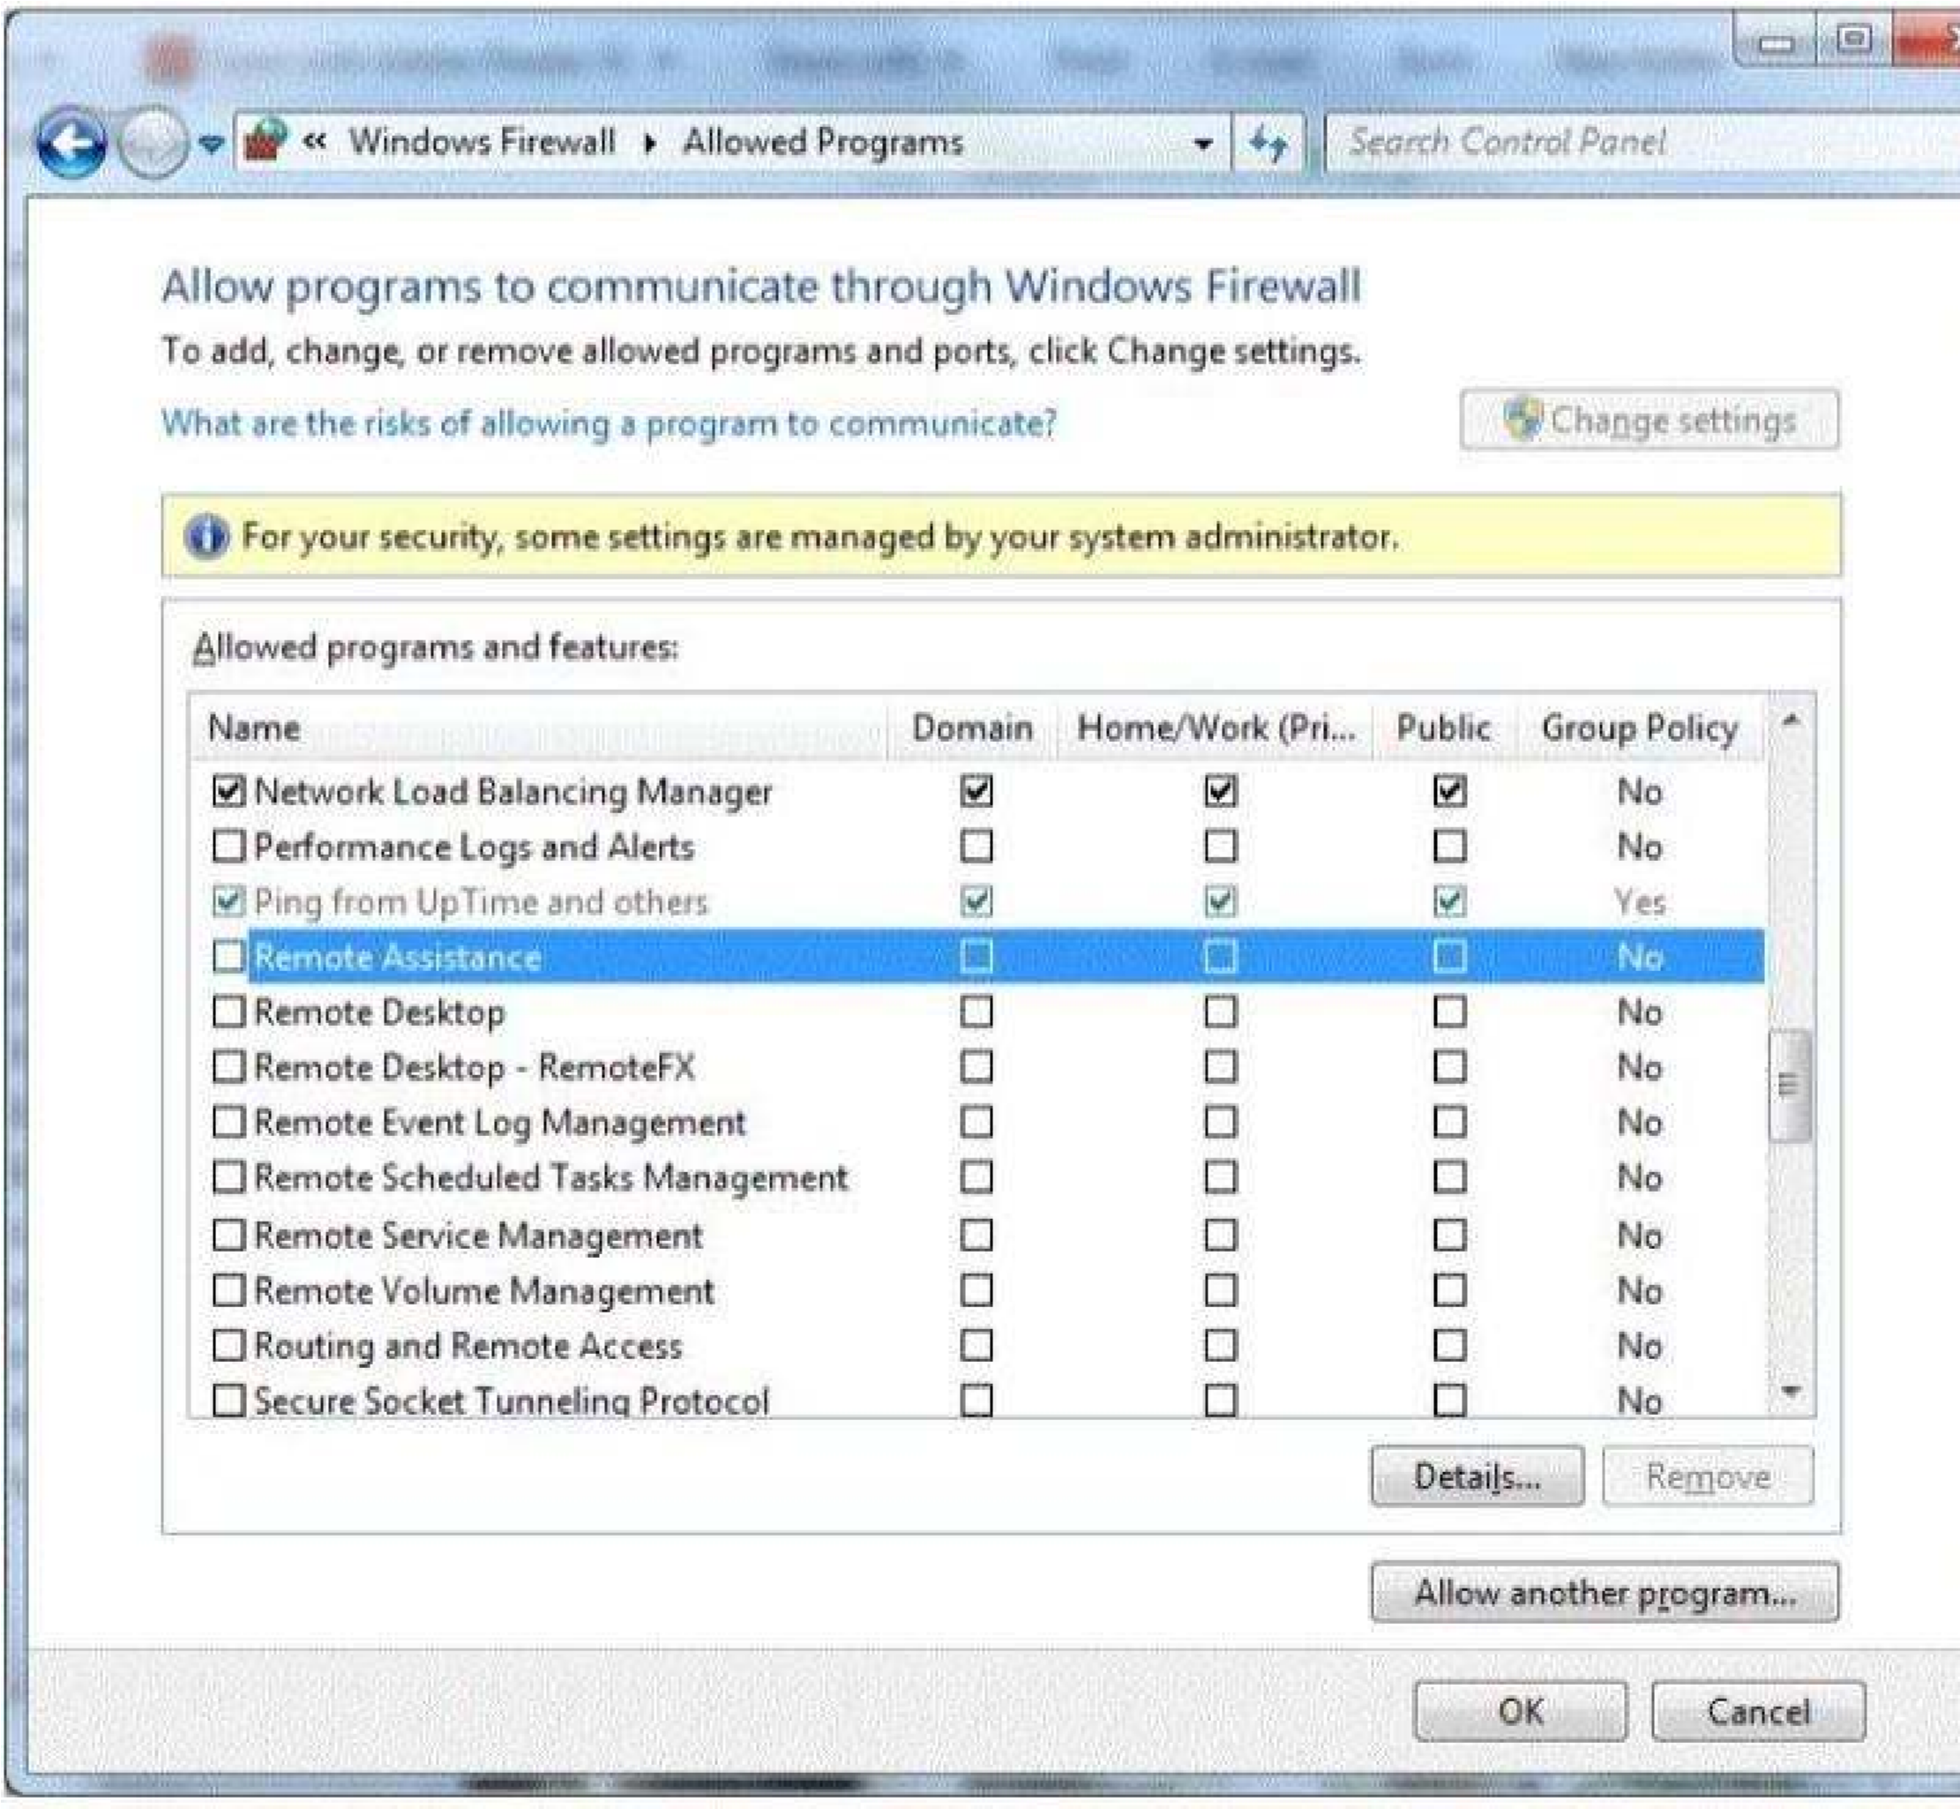Your firewall configuration is shown in the following image:

You need to allow Remote Desktop to be able to get through your firewall for users on your company's network.

Which settings should you enable?

Remote Assistance: Home/Work (Private)

Remote Desktop: Public

Remote Desktop: Home/Work (Private)

Remote Assistance: Domain

**Correct Answer:** A **Section: (none) Explanation**

**Explanation/Reference:**

**QUESTION 40**

You are trying to connect to an FTP server on the Internet from a computer in a school lab. You cannot get a connection. You try on another computer with the same results. The computers in the lab are able to browse the Internet.

You are able to connect to this FTP server from home.

What could be blocking the connection to the server?

A layer-2 switch

A wireless access point

A firewall

A layer-2 hub

**Correct Answer:** C

**Section: (none) Explanation**

**Explanation/Reference:**

**QUESTION 41**

What does NAT do?

It encrypts and authenticates IP packets.

It provides caching and reduces network traffic.

It translates public IP addresses to private addresses and vice versa.

It analyzes incoming and outgoing traffic packets.

**Correct Answer:** C

**Section: (none) Explanation**

**Explanation/Reference:**

Reference: http://en.wikipedia.org/wiki/Network_address_translation

**QUESTION 42**

The default password length for a Windows Server domain controller is:

0

5

7

14

**Correct Answer:** C

**Section: (none) Explanation**

**Explanation/Reference:**

**QUESTION 43**

You create a web server for your school. When users visit your site, they get a certificate error that says your site is not trusted.

What should you do to fix this problem?

Install a certificate from a trusted Certificate Authority (CA).

Use a digital signature.

Generate a certificate request.

Enable Public Keys on your website.

**Correct Answer:** A

**Section: (none) Explanation**

**Explanation/Reference:**

**QUESTION 44**

What is an example of non-propagating malicious code?

A back door

A hoax

A Trojan horse

A worm

**Correct Answer:** A

**Section: (none) Explanation**

**Explanation/Reference:**

**QUESTION 45**

A brute force attack:

Uses response filtering

Tries all possible password variations

Uses the strongest possible algorithms

Targets all the ports

**Correct Answer:** B

**Section: (none) Explanation**

**Explanation/Reference:**

**QUESTION 46**

Humongous Insurance is an online healthcare insurance company. During an annual security audit a security firm tests the strength of the company's password policy and suggests that Humongous Insurance implement password history policy.

What is the likely reason that the security firm suggests this?

Past passwords were easily cracked by the brute force method.

Past passwords of users contained dictionary words.

Previous password breaches involved use of past passwords.

Past passwords lacked complexity and special characters.

**Correct Answer:** B

**Section: (none)**

**Explanation**

**Explanation/Reference:**

**QUESTION 47**

The WPA2 PreShared Key (PSK) is created by using a passphrase (password) and salting it with the WPS PIN.

Select the correct answer if the underlined text does not make the statement correct. Select "No change is needed" if the underlined text makes the statement correct.

Service Set Identifier (SSID)

Admin password

WEP key

No change is needed

**Correct Answer:** A

**Section: (none) Explanation**

**Explanation/Reference:**

**QUESTION 48**

What are three major attack vectors that a social engineering hacker may use? (Choose three.)

Telephone

Reverse social engineering

Waste management

Honey pot systemsE. Firewall interface

**Correct Answer:** ABC

**Section: (none) Explanation**

**Explanation/Reference:**

**QUESTION 49**

Which two security settings can be controlled by using group policy? (Choose two.)

Password complexity

Access to the Run... command

Automatic file locking

Encrypted access from a smart phone

**Correct Answer:** AB

**Section: (none) Explanation**

**Explanation/Reference:**

Reference: http://technet.microsoft.com/en-us/library/cc875814.aspx

**QUESTION 50**

Cookies impact security by enabling: (Choose two.)

Storage of Web site passwords.

Higher security Web site protections.

Secure Sockets Layer (SSL).

Web sites to track browsing habits.

**Correct Answer:** AD

**Section: (none) Explanation**

**Explanation/Reference:**

Reference: http://en.wikipedia.org/wiki/HTTP_cookie

**QUESTION 51**

To keep third-party content providers from tracking your movements on the web, enable InPrivate Browsing. Select the correct answer if the underlined text does not make the statement correct. Select "No change is needed'' if the underlined text makes the statement correct.

InPrivate Filtering

SmartScreen Filter

Compatibility Mode

No change is needed

**Correct Answer:** A

**Section: (none) Explanation**

**Explanation/Reference:**

**QUESTION 52**

Which enables access to all of the logged-in user's capabilities on a computer?

Java applets

ActiveX controls

Active Server Pages (ASP)

Microsoft Silverlight

**Correct Answer:** B

**Section: (none) Explanation**

**Explanation/Reference:**

**QUESTION 53**

You need to install a domain controller in a branch office. You also need to secure the information on the domain controller. You will be unable to physically secure the server.

Which should you implement?

Read-Only Domain Controller

Point-to-Point Tunneling Protocol (PPTP)

Layer 2 Tunneling Protocol (L2TP)

Server Core Domain Controller

**Correct Answer:** A

**Section: (none) Explanation**

**Explanation/Reference:**

Explanation:

A read-only domain controller (RODC) is a new type of domain controller in the Windows Server® 2008 operating system. With an RODC, organizations can easily deploy a domain controller in locations where physical security cannot be guaranteed. An RODC hosts read-only partitions of the Active Directory® Domain Services (AD DS) database. Explanation: http://technet.microsoft.com/en-us/library/cc732801 (v=ws.10).aspx

**QUESTION 54**

E-mail spoofing:

Forwards e-mail messages to all contacts

Copies e-mail messages sent from a specific user

Obscures the true e-mail sender

Modifies e-mail routing logs

**Correct Answer:** C

**Section: (none) Explanation**

**Explanation/Reference:**

Reference: http://www.microsoft.com/mscorp/safety/technologies/senderid/technology.mspx

**QUESTION 55**

What is the primary advantage of using Active Directory Integrated Zones?

Zone encryption

Password protection

Non-repudiation

Secure replication

**Correct Answer:** D

**Section: (none) Explanation**

**Explanation/Reference:**

Reference: http://books.google.com/books?id=CXy-2LBZCVgC&pg=PA201&dq= %22Active+Directory

+Integrated+Zones%22,+Secure+replication&hl=en&sa=X&ei=9s92U- v1KI-

zyASjzILIDg&ved=0CE0Q6AEwAQ#v=onepage&q=%22Active%20Directory %20Integrated%20Zones% 22%2C%20Secure%20replication&f=false

**QUESTION 56**

Which two are included in an enterprise antivirus program? (Choose two.)

Attack surface scanning

On-demand scanning

Packet scanning

Scheduled scanning

**Correct Answer:** BD

**Section: (none) Explanation**

**Explanation/Reference:**

**QUESTION 57**

Phishing is an attempt to:

Obtain information by posing as a trustworthy entity.

Limit access to e-mail systems by authorized users.

Steal data through the use of network intrusion.

Corrupt e-mail databases through the use of viruses.

**Correct Answer:** A

**Section: (none) Explanation**

**Explanation/Reference:**

Explanation:

Phishing is the act of attempting to acquire sensitive information such as usernames, passwords, and credit card details (and sometimes, indirectly, money) by masquerading as a trustworthy entity in an electronic communication.

**QUESTION 58**

Humongous Insurance needs to set up a domain controller in a branch office. Unfortunately, the server cannot be sufficiently secured from access by employees in that office, so the company is installing a Primary Domain Controller.

Select the correct answer if the underlined text does not make the statement correct. Select "No change is needed" if the underlined text makes the statement correct.

Read-Only Domain Controller

Backup Domain Controller

Active Directory Server

No change is needed.

**Correct Answer:** A

**Section: (none) Explanation**

**Explanation/Reference:**

**QUESTION 59**

Where should you lock up the backup tapes for your servers?

The server room

A filing cabinet

The tape library

An offsite fire safe

**Correct Answer:** D

**Section: (none) Explanation**

**Explanation/Reference:**

Explanation:

Backup tapes should be stored off site, preferably in a fire safe, so that the data is available should a fire, flood, or other disaster affect the location were the servers are.

**QUESTION 60**

Which is a special folder permission?

Read

Modify

Write

Delete

**Correct Answer:** D

**Section: (none)**

**Explanation**

**Explanation/Reference:**

Reference: http://support.microsoft.com/kb/308419

**QUESTION 61**

When conducting a security audit the first step is to:

Inventory the company's technology assets

Install auditing software on your servers

Set up the system logs to audit security events

Set up a virus quarantine area

**Correct Answer:** A

**Section: (none) Explanation**

**Explanation/Reference:**

**QUESTION 62**

You are an intern at Litware, Inc. Your manager asks you to make password guess attempts harder by limiting login attempts on company computers.

What should you do?

Enforce password sniffing.

Enforce password history.

Make password complexity requirements higher.

Implement account lockout policy.

**Correct Answer:** D

**Section: (none) Explanation**

**Explanation/Reference:**

Reference: http://technet.microsoft.com/en-us/library/dd277400.aspx

**QUESTION 63**

You need to grant a set of users write access to a file on a network share. You should add the users to:

A security group

The Authenticated Users group

The Everyone group

A distribution group

**Correct Answer:** B

**Section: (none) Explanation**

**Explanation/Reference:**

**QUESTION 64**

The certificate of a secure public Web server on the Internet should be:

Issued by a public certificate authority (CA)

Signed by using a 4096-bit key

Signed by using a 1024-bit key

Issued by an enterprise certificate authority (CA)

**Correct Answer:** A

**Section: (none) Explanation**

**Explanation/Reference:**

**QUESTION 65**

Setting a minimum password age restricts when users can:

Request a password reset

Change their passwords

Log on by using their passwords

Set their own password expiration

**Correct Answer:** B

**Section: (none) Explanation**

**Explanation/Reference:**

Explanation:

Configure the minimum password age to be more than 0 if you want Enforce password history to be effective. Without a minimum password age, users can cycle through passwords repeatedly until they get to an old favorite.

**QUESTION 66**

Basic security questions used to reset a password are susceptible to:

Hashing

Social engineering

Network sniffingD. Trojan horses

**Correct Answer:** B

**Section: (none) Explanation**

**Explanation/Reference:**

Reference: http://en.wikipedia.org/wiki/Self-service_password_reset

**QUESTION 67**

You suspect a user's computer is infected by a virus.

What should you do first?

Restart the computer in safe mode

Replace the computer's hard disk drive

Disconnect the computer from the network

Install antivirus software on the computer

**Correct Answer:** D

**Section: (none) Explanation**

**Explanation/Reference:**

**QUESTION 68**

You create a new file in a folder that has inheritance enabled.

By default, the new file:

Takes the permissions of the parent folder

Does not take any permissions

Takes the permissions of other folders in the same directory

Takes the permissions of other files in the same directory

**Correct Answer:** A

**Section: (none) Explanation**

**Explanation/Reference:**

Reference: https://www.microsoft.com/resources/documentation/windows/xp/all/proddocs/en- us/ acl_inherit_permissions.mspx?mfr=true

**QUESTION 69**

Password history policies are used to prevent:

Brute force attacks

Users from sharing passwords

Social engineering

Passwords from being reused immediately

**Correct Answer:** D

**Section: (none) Explanation**

**Explanation/Reference:**

Explanation:

This security setting determines the number of unique new passwords that have to be associated with a user account before an old password can be reused. The value must be between 0 and 24 passwords. This policy enables administrators to enhance security by ensuring that old passwords are not reused continually.

Reference: http://technet.microsoft.com/en-us/library/cc758950(v=ws.10).aspx

**QUESTION 70**

The Active Directory controls, enforces, and assigns security policies and access rights for all users. Select the correct answer if the underlined text does not make the statement correct. Select "No change is needed" if the underlined text makes the statement correct.

NTFS permissions

User Account Control

Registry

No change is needed

**Correct Answer:** D

**Section: (none) Explanation**

**Explanation/Reference:**

**QUESTION 71**

Creating MD5 hash for files is an example of ensuring what?

Confidentiality

Availability

Least privilege

Integrity

**Correct Answer:** D

**Section: (none) Explanation**

**Explanation/Reference:**

Explanation:

The MD5 message-digest algorithm is a widely used cryptographic hash function producing a 128-bit (16byte) hash value, typically expressed in text format as a 32 digit hexadecimal number. MD5 has been utilized in a wide variety of cryptographic applications, and is also commonly used to verify data integrity.

**QUESTION 72**

Which three elements does HTTPS encrypt? (Choose three.)

Browser cookies

Server IP address

Port numbers

Website URL

Login information

**Correct Answer:** ADE

**Section: (none) Explanation**

**Explanation/Reference:**

Reference: http://stackoverflow.com/questions/499591/are-https-urls-encrypted

**QUESTION 73**

The company that you work for wants to set up a secure network, but they do not have any servers. Which three security methods require the use of a server? (Choose three.)

802.1x

WPA2 Personal

WPA2 Enterprise

RADIUS

802.11ac

**Correct Answer:** ACD

**Section: (none) Explanation**

**Explanation/Reference:**

**QUESTION 74**

Shredding documents helps prevent:

Man-in-the-middle attacks

Social engineering

File corruption

Remote code execution

Social networking

**Correct Answer:** B

**Section: (none) Explanation**

**Explanation/Reference:**

Reference: http://technet.microsoft.com/en-us/library/cc875841.aspx

**QUESTION 75**

Dumpster diving refers to a physical threat that a hacker might use to look for information about a computer network.

Select the correct answer if the underlined text does not make the statement correct. Select "No change is needed" if the underlined text makes the statement correct.

Phishing

Malware

Reverse Social engineering

No change is needed

**Correct Answer:** D

**Section: (none) Explanation**

**Explanation/Reference:**

**QUESTION 76**

An attorney hires you to increase the wireless network security for the law firm's office. The office has a very basic network, with just a modem and a router.

Which of these security modes offers the highest security?

WPA-Personal

WEP

WPA2-Personal

WPA-Enterprise

**Correct Answer:** C

**Section: (none) Explanation**

**Explanation/Reference:**

**QUESTION 77**

Which type of firewall allows for inspection of all characteristics of a packet?

NAT

Stateful

Stateless

Windows Defender

**Correct Answer:** B

**Section: (none) Explanation**

**Explanation/Reference:**

Reference: http://en.wikipedia.org/wiki/Stateful_firewall

**QUESTION 78**

You are trying to establish communications between a client computer and a server. The server is not responding.

You confirm that both the client and the server have network connectivity.

Which should you check next?

Microsoft Update

Data Execution Prevention

Windows Firewall

Active Directory Domains and Trusts

**Correct Answer:** D

**Section: (none) Explanation**

**Explanation/Reference:**

**QUESTION 79**

You are an intern and are working remotely.

You need a solution that meets the following requirements:  Allows you to access data on the company network securely

 Gives you the same privileges and access as if you were in the office

What are two connection methods you could use? (Choose two.)

Forward Proxy

Virtual Private Network (VPN)

Remote Access Service (RAS)

Roaming Profiles

**Correct Answer:** BD

**Section: (none) Explanation**

**Explanation/Reference:**

**QUESTION 80**

Network Access Protection (NAP) enables administrators to control access to network resources based on a computer's:

Encryption level

Warranty

Physical location

Configuration

**Correct Answer:** D

**Section: (none) Explanation**

**Explanation/Reference:**

Explanation:

Network Access Protection (NAP) is a new set of operating system components included with the Windows Server® 2008 and Windows Vista® operating systems that provides a platform to help ensure that client computers on a private network meet administrator-defined requirements for system health. NAP policies define the required configuration and update status for a client computer's operating system and critical software. For example, computers might be required to have antivirus software with the latest signatures installed, current operating system updates installed, and a host-based firewall enabled. By enforcing compliance with health requirements, NAP can help network administrators mitigate some of the risk caused by improperly configured client computers that might be exposed to viruses and other malicious software.

**QUESTION 81**

Which technology enables you to filter communications between a program and the Internet?

RADIUS server

Antivirus software

Software firewall

BitLocker To Go

**Correct Answer:** C

**Section: (none) Explanation**

**Explanation/Reference:**

Explanation:

There are two types of firewalls the Hardware Firewall and the Software Firewall. A Software Firewall is a software program and a Hardware Firewall is a piece of hardware. Both have the same objective of filtering communications over a system.

**QUESTION 82**

This question requires that you evaluate the underlined text to determine if it is correct. The first line of defense against attacks from the Internet is a software firewall.

Select the correct answer if the underlined text does not make the statement correct. Select "No change is needed'' if the underlined text makes the statement correct.

hardware firewall

virus software

radius server

No change is needed

**Correct Answer:** A

**Section: (none) Explanation**

**Explanation/Reference:**

**QUESTION 83**

Which attack listens to network traffic of a computer resource?

Resource gathering

Denial of service

ARP poisoning

Eavesdropping

Logic bomb

**Correct Answer:** D

**Section: (none) Explanation**

**Explanation/Reference:**

Explanation:

Eavesdropping

In general, the majority of network communications occur in an unsecured or "cleartext" format, which allows an attacker who has gained access to data paths in your network to "listen in" or interpret (read) the traffic. When an attacker is eavesdropping on your communications, it is referred to as sniffing or snooping. The ability of an eavesdropper to monitor the network is generally the biggest security problem that administrators face in an enterprise. Without strong encryption services that are based on cryptography, your data can be read by others as it traverses the network.

**QUESTION 84**

Which of the following describes a VLAN?

It connects multiple networks and routes data packets.

It is a logical broadcast domain across physical subnets.

It is a subnetwork that reveals a company's externally facing resources to the public network.

It allows different network protocols to communicate between different network segments.

**Correct Answer:** B

**Section: (none) Explanation**

**Explanation/Reference:**

Explanation:

VLAN (Virtual Local Network) is a logically separate IP subnetwork which allow multiple IP networks and subnets to exist on the same-switched network. VLAN is a logical broadcast domain that can span multiple physical LAN segments. It is a modern way administrators configure switches into virtual local-area networks (VLANs) to improve network performance by separating large Layer 2 broadcast domains into smaller ones.

**QUESTION 85**

A network sniffer is software or hardware that:

Records user activity and transmits it to the server

Captures and analyzes network communication

Protects workstations from intrusions

Catalogs network data to create a secure index

**Correct Answer:** B

**Section: (none) Explanation**

**Explanation/Reference:**

Explanation:

A network sniffer is a computer tool that captures network data in the form of low-level packets. Network sniffers can be used for technical troubleshooting and analyzing the communication.

**QUESTION 86**

What is a service set identifier (SSID)?

A wireless encryption standard

The wireless LAN transmission type

The broadcast name of an access point

A wireless security protocol

**Correct Answer:** C

**Section: (none) Explanation**

**Explanation/Reference:**

Explanation:

SSID (service set identifier) is a function performed by an Access Point that transmits its name so that wireless stations searching for a network connection can 'discover' it. It's what allows your wireless adapter's client manager program or Windows built-in wireless software to give you a list of the Access Points in range.

**QUESTION 87**

To implement WPA2 Enterprise, you would need a/an:

RADIUS server

SSL server

WEP server

VPN server

**Correct Answer:** A

**Section: (none) Explanation**

**Explanation/Reference:**

**QUESTION 88**

You would implement a wireless intrusion prevention system to:

Prevent wireless interference

Detect wireless packet theft

Prevent rogue wireless access points

Enforce SSID broadcasting

**Correct Answer:** C

**Section: (none) Explanation**

**Explanation/Reference:**

Reference: http://en.wikipedia.org/wiki/Wireless_intrusion_prevention_system

**QUESTION 89**

The manager of a coffee shop hires you to securely set up WiFi in the shop.

To keep computer users from seeing each other, what should you use with an access point?

Client bridge mode

Client isolation mode

MAC address filtering

Client mode

**Correct Answer:** B

**Section: (none) Explanation**

**Explanation/Reference:**

Explanation:

Wireless Client Isolation is a unique security feature for wireless networks. When Client Isolation is enabled any and all devices connected to the wireless LAN will be unable to talk to each other.

**QUESTION 90**

E-mail bombing attacks a specific entity by:

Redirecting all e-mail to another entity

Sending high volumes of e-mail

Tracing e-mail to the destination address

Triggering high levels of security alerts

**Correct Answer:** B

**Section: (none) Explanation**

**Explanation/Reference:**

Explanation:

In Internet usage, an email bomb is a form of net abuse consisting of sending huge volumes of email to an address in an attempt to overflow the mailbox or overwhelm the server where the email address is hosted in a denial-of-service attack.

**QUESTION 91**

How does the sender policy framework (SPF) aim to reduce spoofed email?

It provides a list of IP address ranges for particular domains so senders can be verified.

It includes an XML policy file with each email that confirms the validity of the message.

It lists servers that may legitimately forward mail for a particular domain.

It provides an encryption key so that authenticity of an email message can be validated

**Correct Answer:** A

**Section: (none) Explanation**

**Explanation/Reference:**

**QUESTION 92**

Windows Server Update Services (WSUS) is a tool that:

Updates data stored in Windows servers

Manages the services that run on a server

Updates licensing for Windows servers

Manages updates for Microsoft software

**Correct Answer:** D

**Section: (none) Explanation**

**Explanation/Reference:**

Explanation:

Windows Server Update Services (WSUS) enables information technology administrators to deploy the latest Microsoft product updates to computers that are running the Windows operating system. By using WSUS, administrators can fully manage the distribution of updates that are released through Microsoft Update to computers in their network. Reference: http://technet.microsoft.com/en-us/windowsserver/ bb332157.aspx

**QUESTION 93**

Which two characteristics should you recommend for a user's domain password? (Choose two.)

Hard to guess

Includes Unicode characters

Easy to remember

Easy to increment

**Correct Answer:** AC

**Section: (none) Explanation**

**Explanation/Reference:**

Reference: http://www.usewisdom.com/computer/passwords.html

**QUESTION 94**

To protect systems from buffer overflow errors, you can use:

Antivirus software

Data Execution Prevention

A proxy server

An Intruder Prevention System

**Correct Answer:** B

**Section: (none) Explanation**

**Explanation/Reference:**

**QUESTION 95**

You sign up for an online bank account. Every 6 months, the bank requires you to change your password. You have changed your password 5 times in the past. Instead of coming up with a new password, you decide to use one of your past passwords, but the bank's password history prevents you on doing so.

Select the correct answer if the underlined text does not make the statement correct Select "No change is needed" if the underlined text makes the statement correct.

Minimum password age

Maximum password duration

Password complexity

No change is needed.

**Correct Answer:** D

**Section: (none) Explanation**

**Explanation/Reference:**

**QUESTION 96**

You need to prevent unauthorized users from reading a specific file on a portable computer if the portable computer is stolen.

What should you implement?

File-level permissions

Advanced Encryption Standard (AES)

Folder-level permissions

Distributed File System (DFS)

BitLocker

**Correct Answer:** E

**Section: (none) Explanation**

**Explanation/Reference:**

Reference: http://4sysops.com/archives/seven-reasons-why-you-need-bitlocker-hard-drive- encryption-foryour-whole-organization/

**QUESTION 97**

Your password is 1Vu*cI!8sT.

Which attack method is your password vulnerable to?

Rainbow table

Brute force

Spidering

Dictionary

**Correct Answer:** A

**Section: (none) Explanation Explanation/Reference:**

**QUESTION 98**

You have a Windows 7 desktop computer, and you create a Standard User account for your roommate so that he can use the desktop from time to time. Your roommate has forgotten his password.

Which two actions can you take to reset the password? (Choose two.)

Use your password reset disk.

Use your administrator account.

Boot into Safe Mode with your roommate's account.

From your roommate's account press CTRL+ALT+DELETE, and then click Change a password.

**Correct Answer:** AB

**Section: (none) Explanation**

**Explanation/Reference:**

**QUESTION 99**

You have two servers that run Windows Server. All drives on both servers are formatted by using NTFS.

You move a file from one server to the other server. The file's permissions in the new location will:

Enable full access to the everyone group

Restrict access to the Administrators group

Inherit the destination folder's permissions

Retain the original folder's permissions

**Correct Answer:** C

**Section: (none) Explanation**

**Explanation/Reference:**

Explanation:

You can modify how Windows Explorer handles permissions when objects are copied or moved to another NTFS volume. When you copy or move an object to another volume, the object inherits the permissions of its new folder.

**QUESTION 100**

Alice sends her password to the game server in plaintext. Chuck is able to observe her password as shown in the following image:

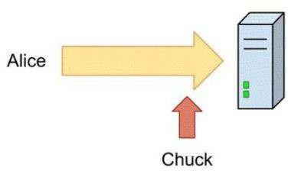

Use the drop-down menus to select the answer choice that completes each statement. Each

correct selection is worth one point.

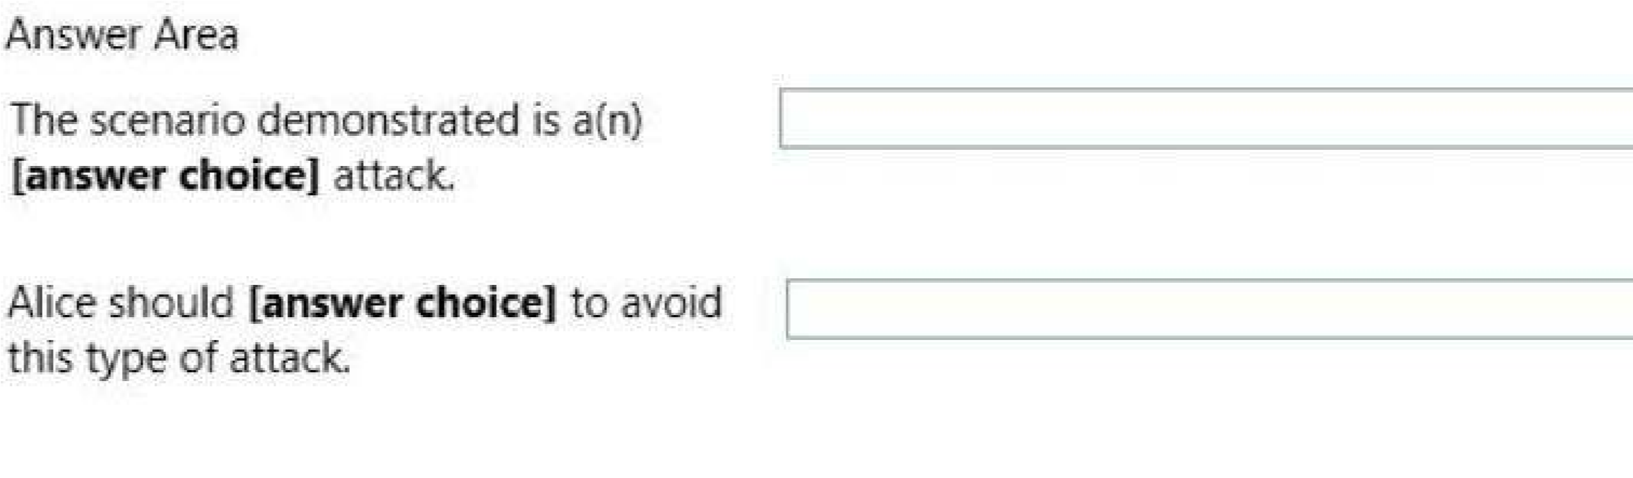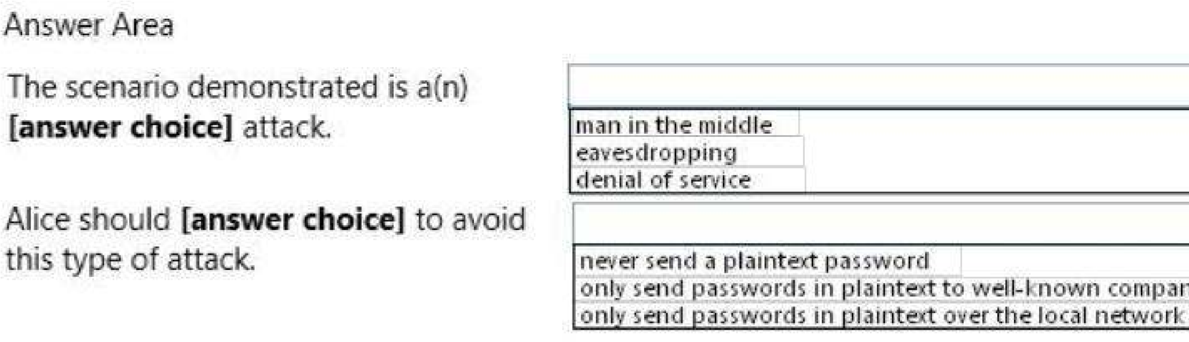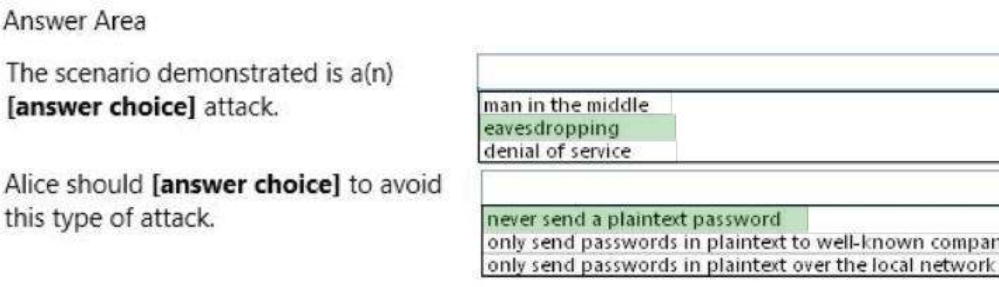**Hot Area:**

**Correct Answer:**

**Section: (none) Explanation**

**Explanation/Reference:**

**QUESTION 101**

For each of the following statements, select Yes if the statement is true. Otherwise, select No.

Each correct selection is worth one point.

**Hot Area:**

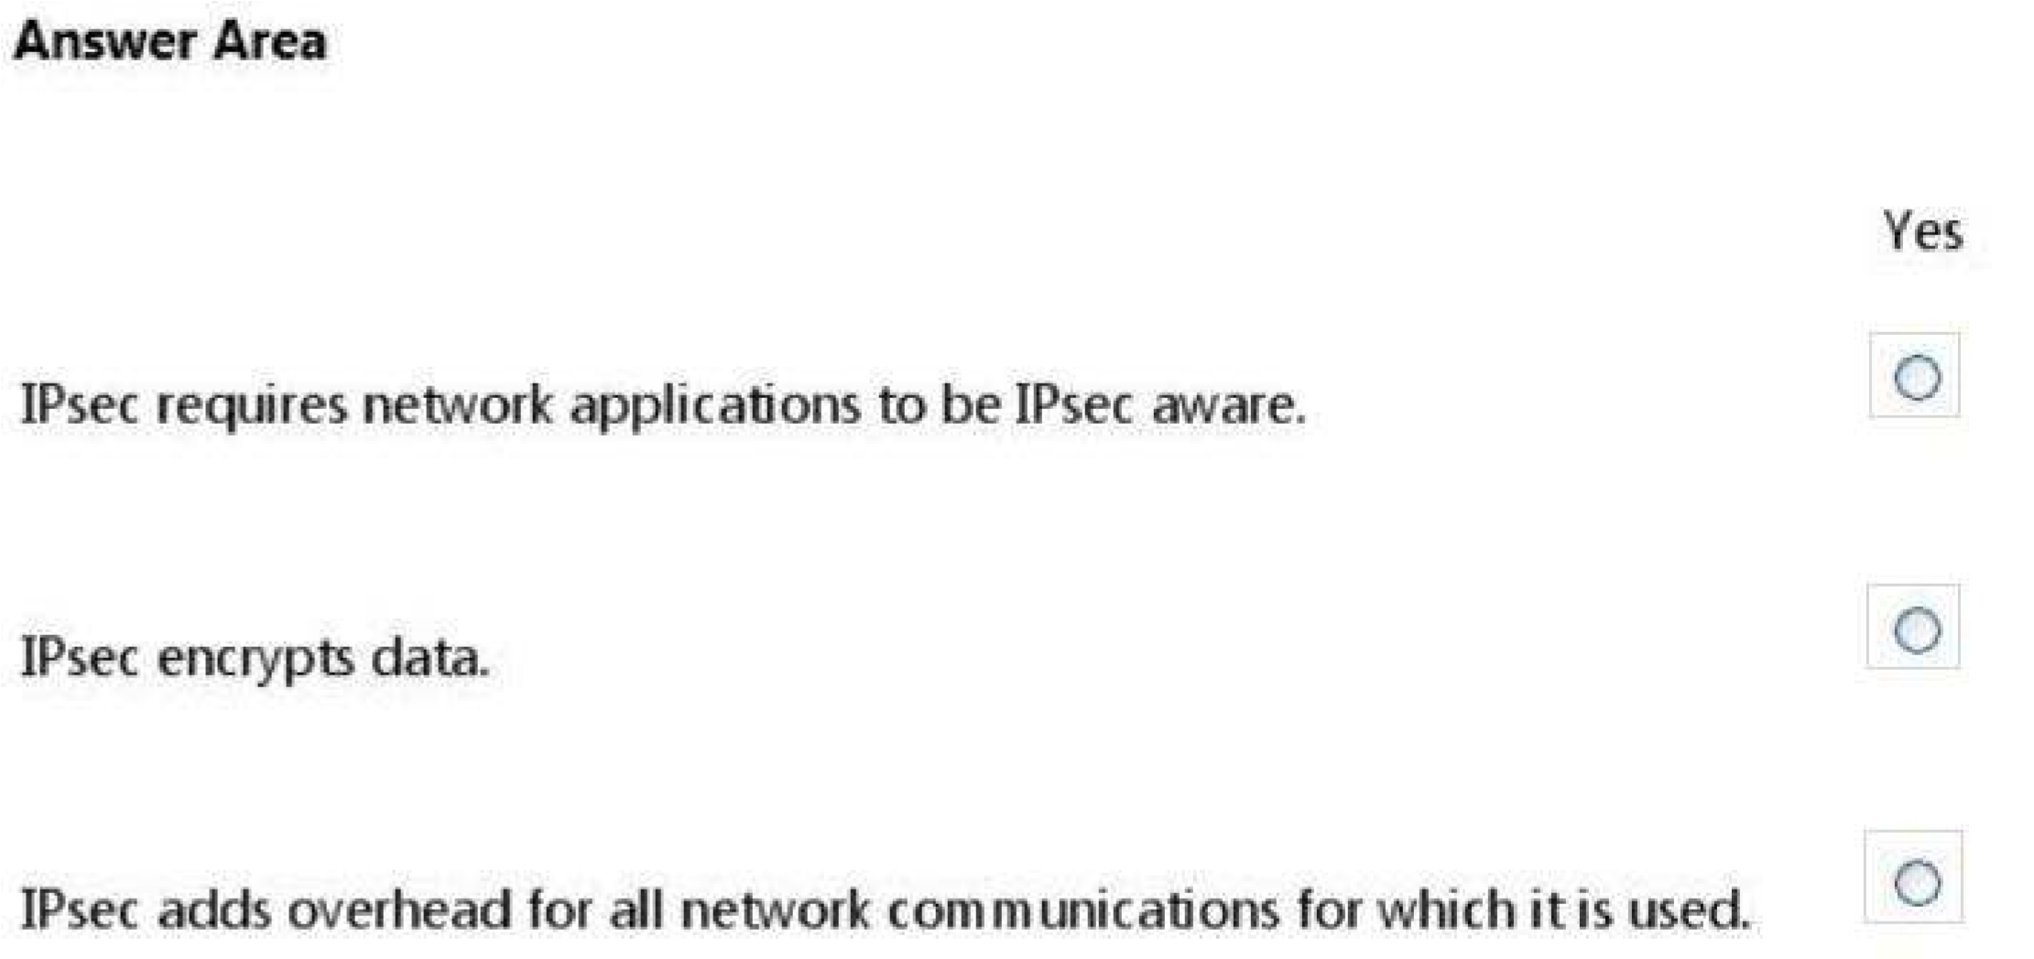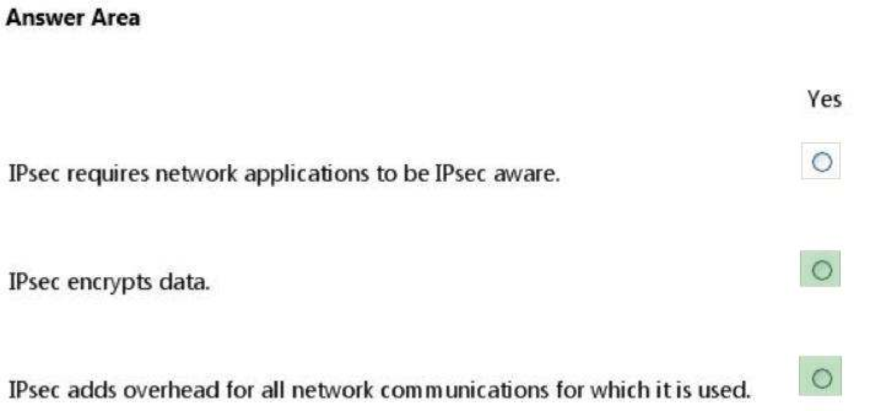**Correct Answer:**

**Section: (none) Explanation**

**Explanation/Reference:**

**QUESTION 102**

For each of the following statements, select Yes if the statement is true. Otherwise, select No.

Each correct selection is worth one point.

**Hot Area:**

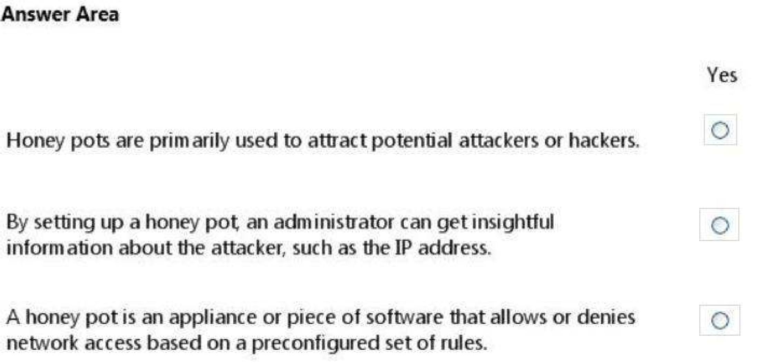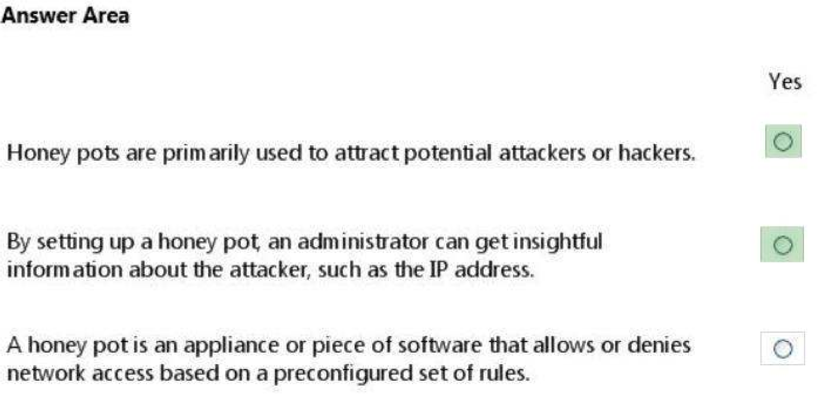**Correct Answer:**

**Section: (none) Explanation**

**Explanation/Reference:**

**QUESTION 103**

For each of the following statements, select Yes if the statement is true. Otherwise, select No.

Each correct selection is worth one point.

**Hot Area:**

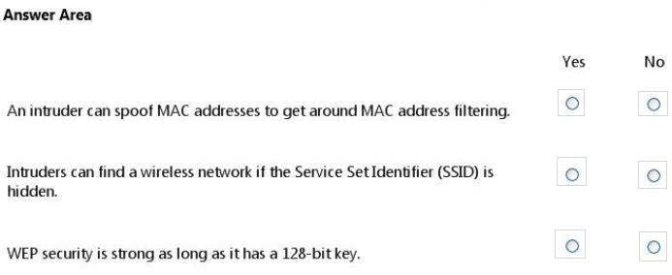

**Correct Answer:**

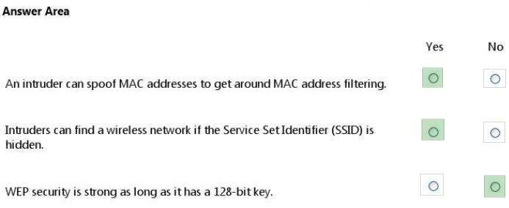

**Section: (none) Explanation**

**Explanation/Reference:**

**QUESTION 104**

You are an intern for a company where your manager wants to be sure you understand the social

engineering threats that may occur. Your manager emphasizes the principles of the Microsoft

Defense-in-Depth Security Model shown in the following image:

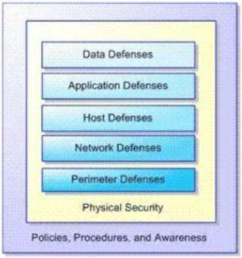

Use the drop-down menus to select the answer choice that completes each statement. Each

correct selection is worth one point.

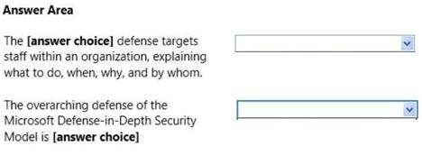

**Hot Area:**

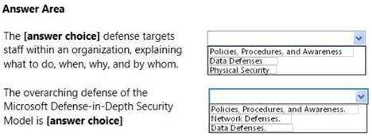

**Correct Answer:**

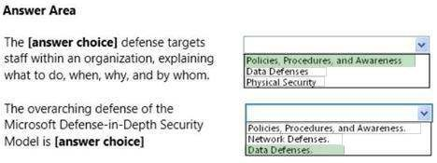

**Section: (none) Explanation**

**Explanation/Reference:**

**QUESTION 105**

For each of the following statements, select Yes if the statement is true. Otherwise, select No.

Each correct selection is worth one point.

**Hot Area:**

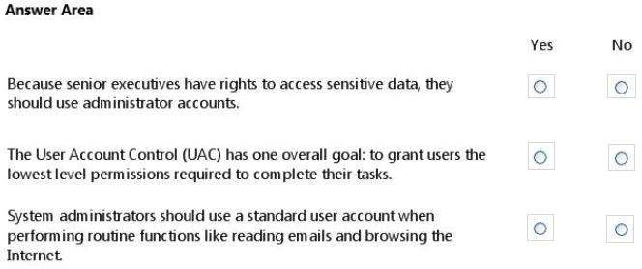

**Correct Answer:**

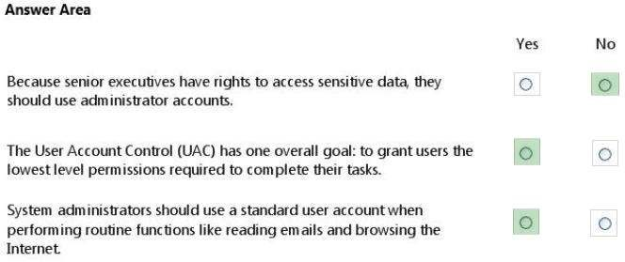

**Section: (none) Explanation**

**Explanation/Reference:**

**QUESTION 106**

For each of the following statements, select Yes if the statement is true. Otherwise, select No.

Each correct selection is worth one point.

**Hot Area:**

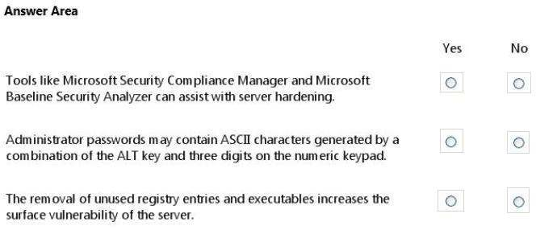

**Correct Answer:**

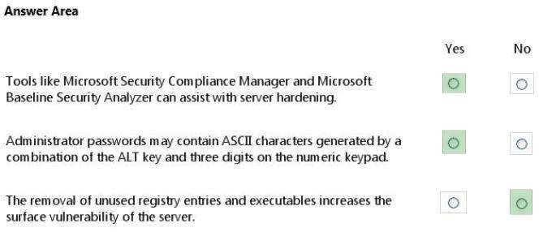

**Section: (none) Explanation**

**Explanation/Reference:**

**QUESTION 107**

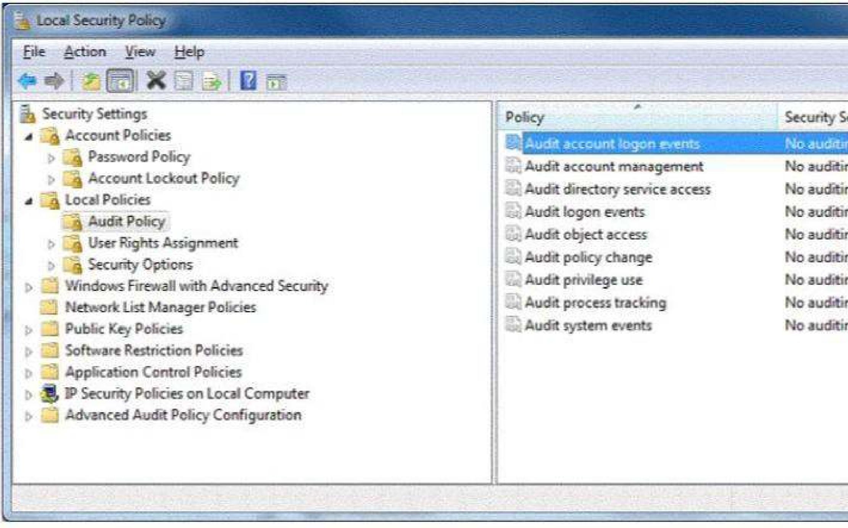You are preparing a local audit policy for your workstation. No auditing is enabled. The settings of your policy are shown in the following image:

Use the drop-down menus to select the answer choice that completes each statement. Each

correct selection is worth one point.

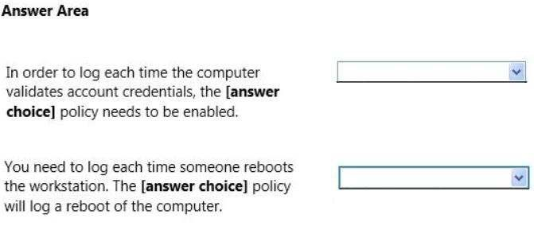

**Hot Area:**

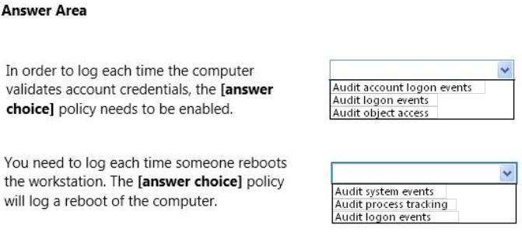

**Correct Answer:**

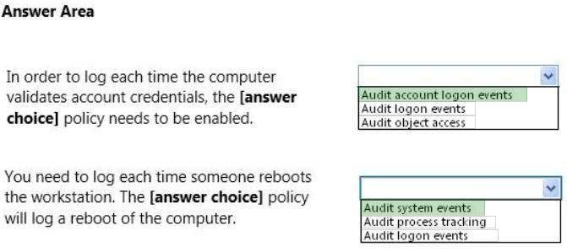

**Section: (none) Explanation**

**Explanation/Reference:** Explanation:

Dozens of events can be audited in Windows. The events fall into several categories:

 Audit account logon events - audit each instance of a user logging on to or logging off from another computer in which this computer is used to validate the account. This event category is applicable to domain controllers only since DC’s are used to validate accounts in domains.

 Audit account management - audit each event of account management on a computer. Examples of account maintenance include password changes, user account and group modifications.

 Audit directory service access - audit the event of a user accessing an Active Directory object that has its own system access control list (SACL) specified.

 Audit logon events - audit each instance of a user logging on to or logging off from a computer. Note that this is different than the ‘Audit account login events’ category. This tracks the logon event to a specific server. The former tracks which domain controller authenticated the user.

Audit object access - audit the event of a user accessing an object that has its own system access control list (SACL) specified. Examples of objects are files, folders, registry keys, printers, etc.

Audit policy change - audit every incident of a change to user rights assignment  policies, audit policies, or trust policies.

 Audit privilege use - audit each instance of a user exercising a user right.

 Audit process tracking - audit detailed tracking information for events such as program activation, process exit, handle duplication, and indirect object access.

 Audit system events - audit when a user restarts or shuts down the computer or when an event occurs that affects either the system security or the security log. Reference: http://www.petri.co.il/windows_auditing.htm

**QUESTION 108**

You are at school and logged in to a Windows 7 computer using a standard user account.

You need to change some of the properties of a desktop icon for an assignment. Your instructor

provides you with an administrator username and password and asks you to do two tasks.

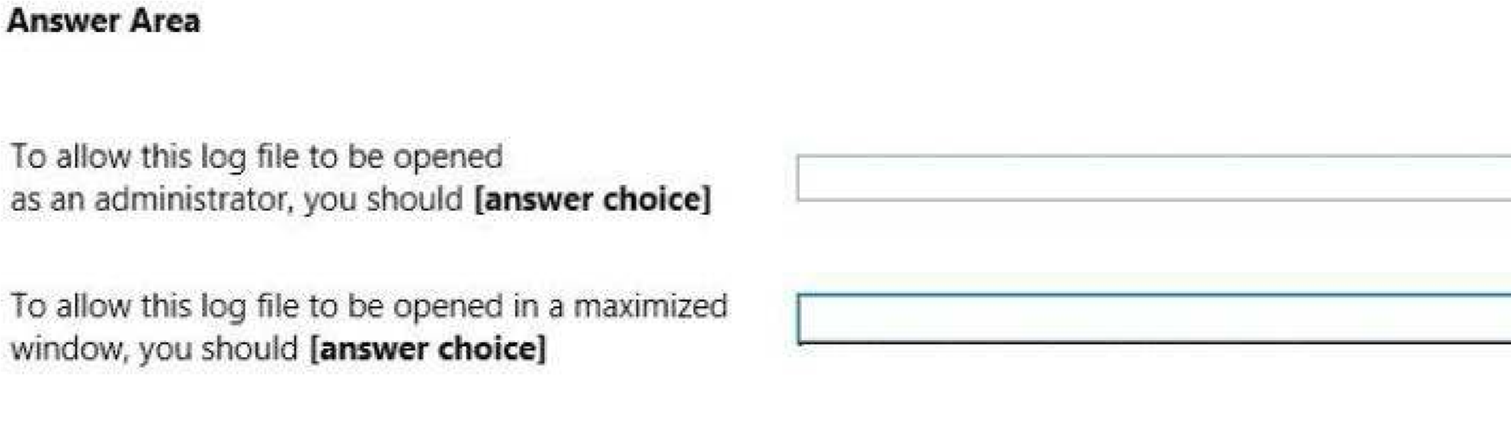When you open the Need Admin Access Properties window, you see the following image:

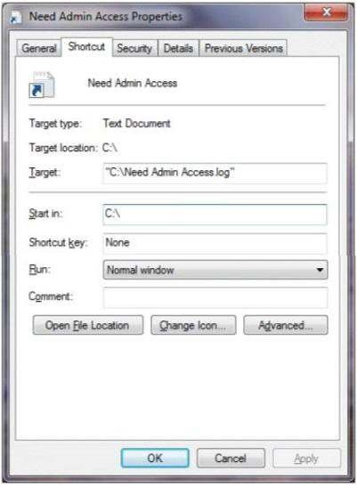

Use the drop-down menus to select the answer choice that completes each statement. Each

correct selection is worth one point.

**Hot Area:**

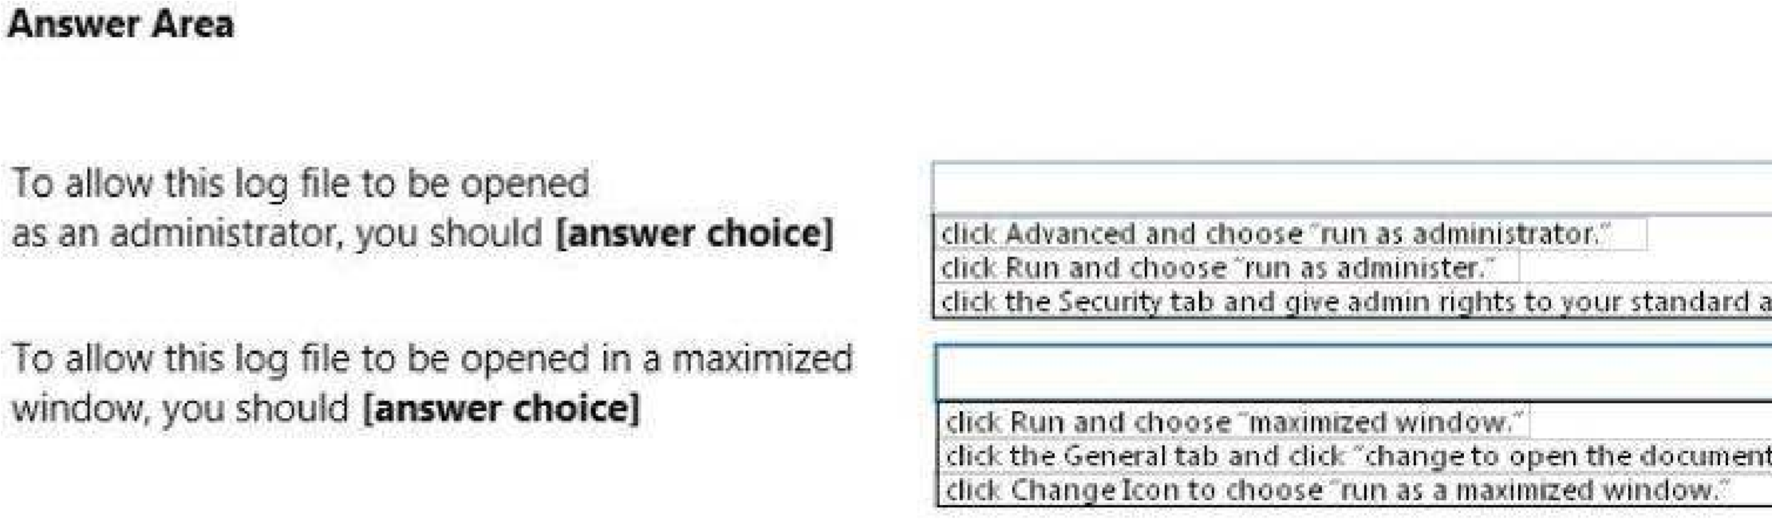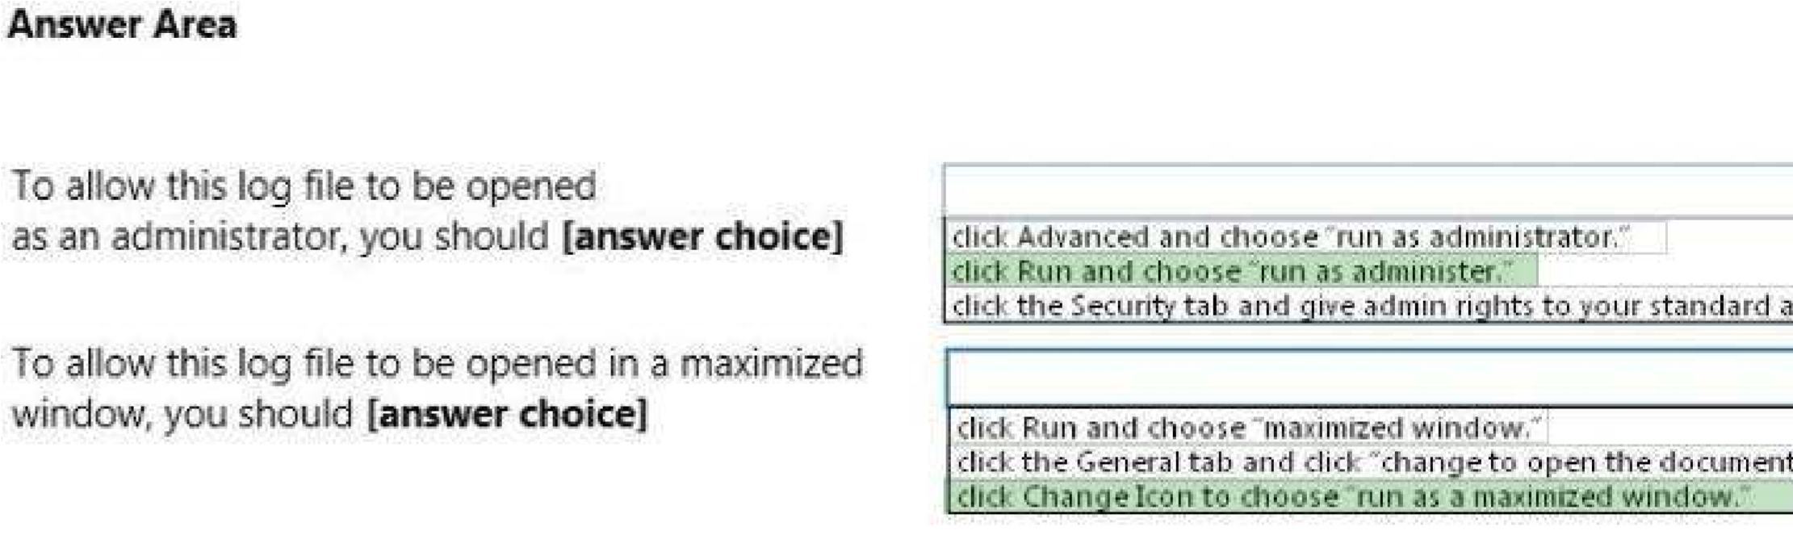**Correct Answer:**

**Section: (none) Explanation**

**Explanation/Reference:**

**QUESTION 109**

For each of the following statements, select Yes if the statement is true. Otherwise, select No.

Each correct selection is worth one point.

**Hot Area:**

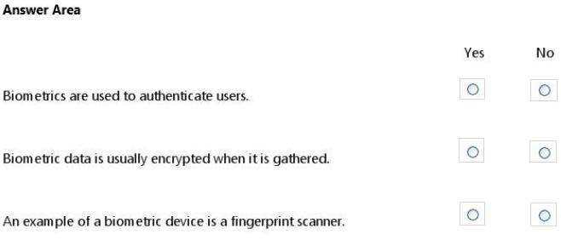

**Correct Answer:**

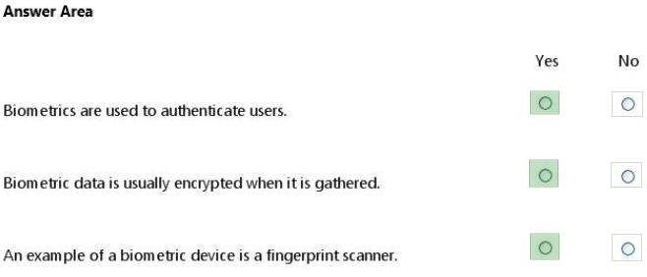

**Section: (none) Explanation**

**Explanation/Reference:** Explanation:

Biometric devices, such as finger scanners consist of a reader or scanning device, Software that

converts the scanned information into digital form and compares match points, and a database

that stores the biometric data for comparison. To prevent identity theft, biometric data is usually encrypted when it is gathered.

**QUESTION 110**

For each of the following statements, select Yes if the statement is true. Otherwise, select No.

Each correct selection is worth one point.

**Hot Area:**

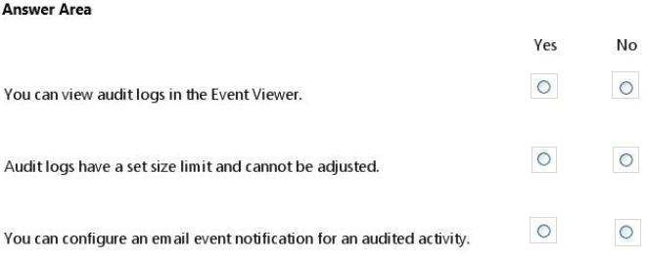

**Correct Answer:**

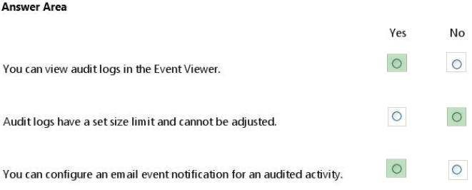

**Section: (none) Explanation**

**Explanation/Reference:**

**QUESTION 111**

For each of the following statements, select Yes if the statement is true. Otherwise, select No.

Each correct selection is worth one point.

**Hot Area:**

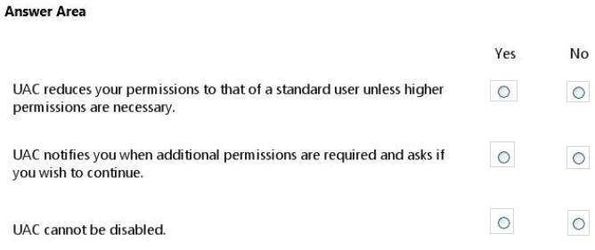

**Correct Answer:**

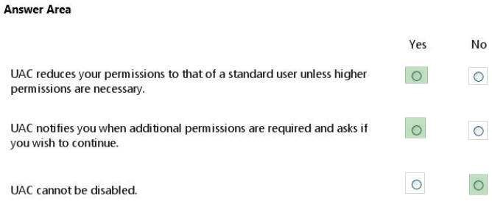

**Section: (none) Explanation**

**Explanation/Reference:**

**QUESTION 112**

For each of the following statements, select Yes if the statement is true. Otherwise, select No.

Each correct selection is worth one point.

**Hot Area:**

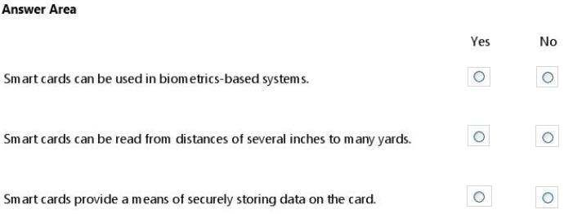

**Correct Answer:**

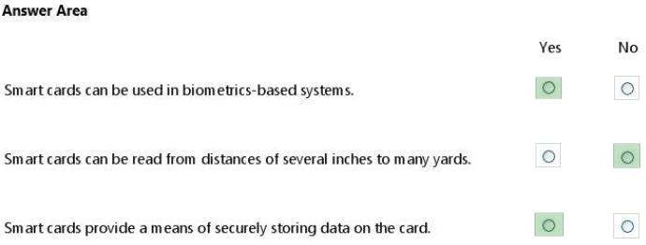

**Section: (none) Explanation**

**Explanation/Reference:**

**QUESTION 113**

Your supervisor asks you to review file permission settings on the application.bat file.

You need to report which file system the file is on and the type of permission the file has. You review the application Properties dialog box shown in the following image:

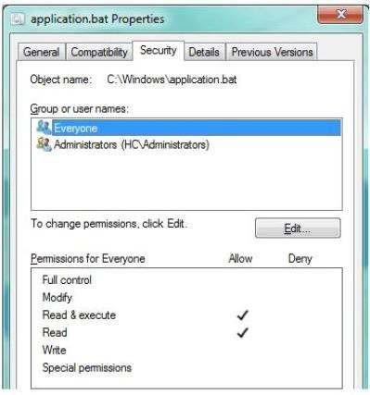

Use the drop-down menus to select the answer choice that completes each statement. Each

correct selection is worth one point.

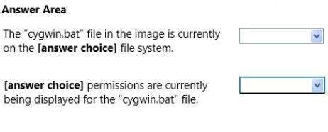

**Hot Area:**

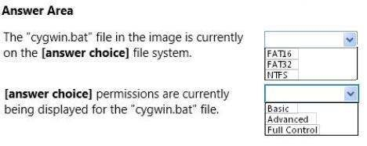

**Correct Answer:**

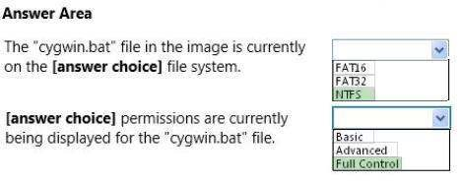

**Section: (none) Explanation**

**Explanation/Reference:**

**QUESTION 114**

For each of the following statements, select Yes if the statement is true. Otherwise, select No.

Each correct selection is worth one point.

**Hot Area:**

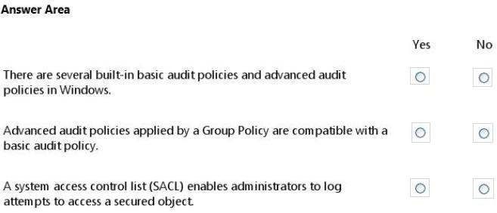

**Correct Answer:**

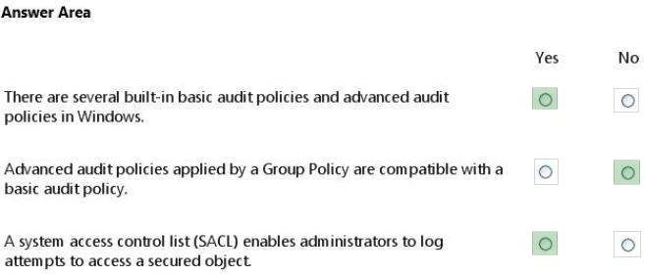

**Section: (none) Explanation**

**Explanation/Reference:**

**QUESTION 115**

For each of the following statements, select Yes if the statement is true. Otherwise, select No.

Each correct selection is worth one point.

**Hot Area:**

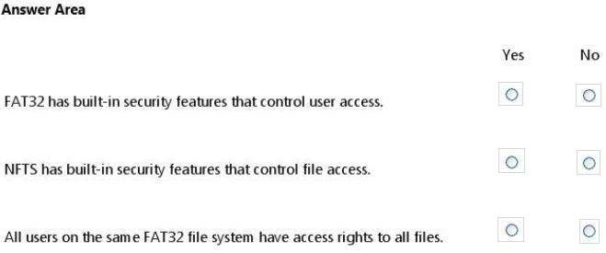

**Correct Answer:**

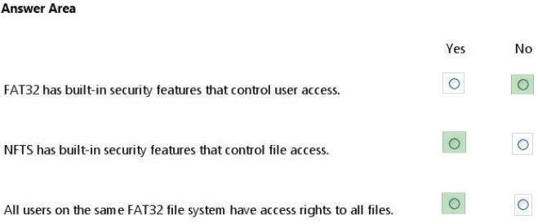

**Section: (none) Explanation**

**Explanation/Reference:**

**QUESTION 116**

For each of the following statements, select Yes if the statement is true. Otherwise, select No.

Each correct selection is worth one point.

**Hot Area:**

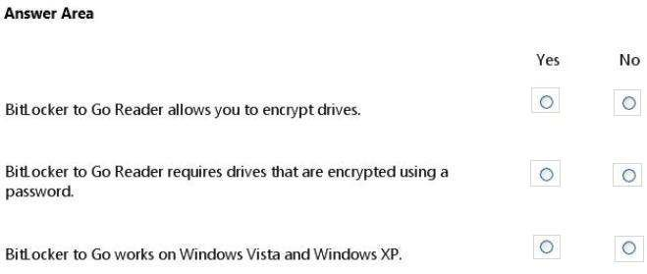

**Correct Answer:**

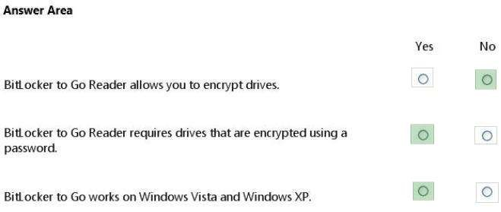

**Section: (none) Explanation**

**Explanation/Reference:**

**QUESTION 117**

For each of the following statements, select Yes if the statement is true. Otherwise, select No.

Each correct selection is worth one point.

**Hot Area:**

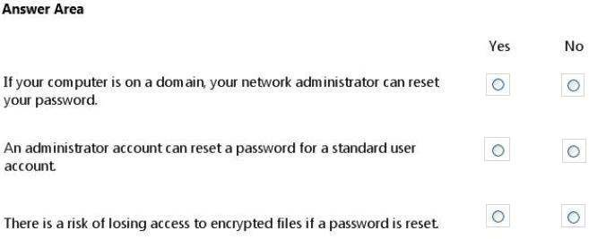

**Correct Answer:**

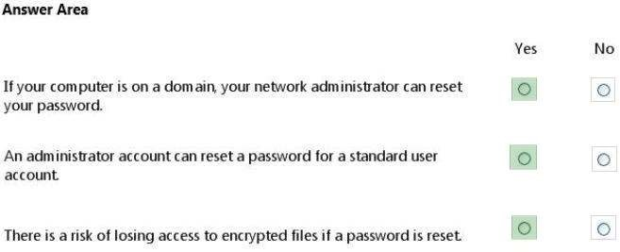

**Section: (none) Explanation**

**Explanation/Reference:**

**QUESTION 118**

You are preparing an audit policy for the workstations at Contoso, Ltd. Currently, no advanced auditing is enabled. The workstations are not members of the domain.

The settings of your Advanced Audit Policy Configuration are shown in the following image:

Use the drop-down menus to select the answer choice that completes each statement. Each

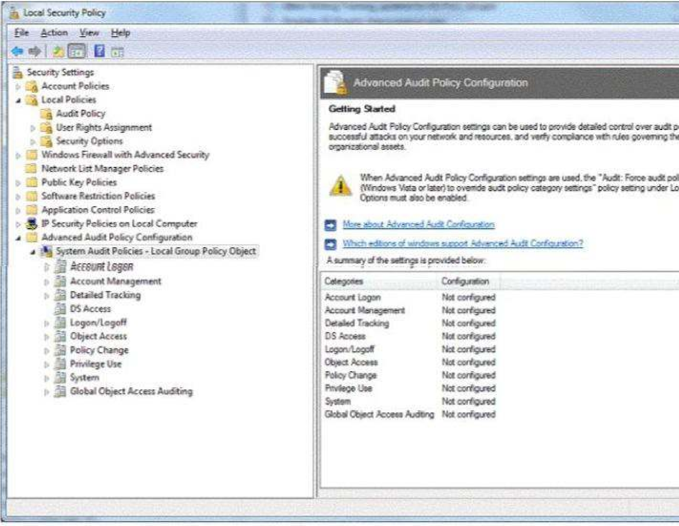correct selection is worth one point.

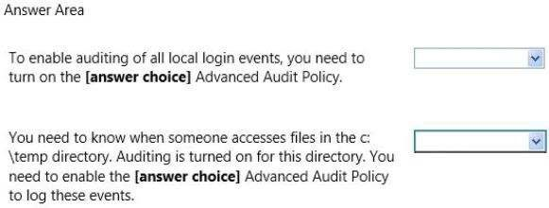

**Hot Area:**

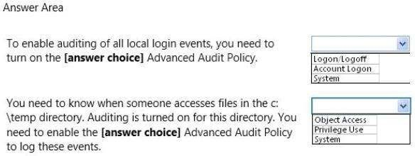

**Correct Answer:**

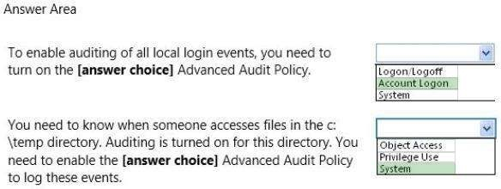

**Section: (none) Explanation**

**Explanation/Reference:**

**QUESTION 119**

An employee where you work is unable to access the company message board in Internet

Explorer.

You review her Internet Options dialog box, as shown in the following image:

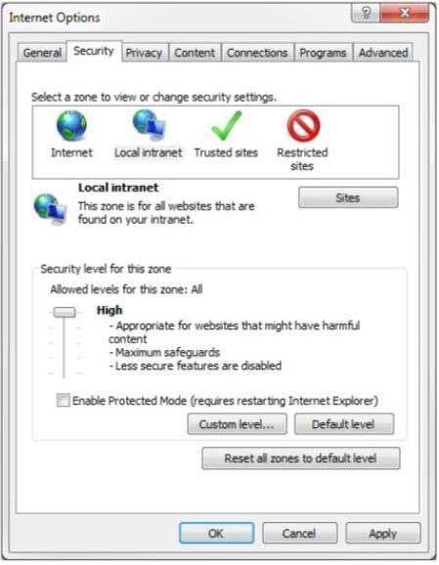

Use the drop-down menus to select the answer choice that completes each statement. Each

correct selection is worth one point.

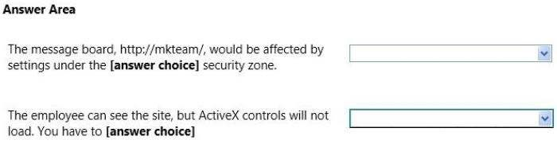

**Hot Area:**

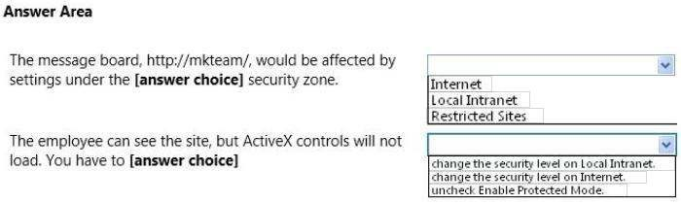

**Correct Answer:**

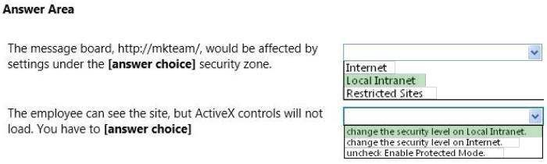

**Section: (none) Explanation**

**Explanation/Reference:**

**QUESTION 120**

For each of the following statements, select Yes if the statement is true. Otherwise, select No.

Each correct selection is worth one point.

**Hot Area:**

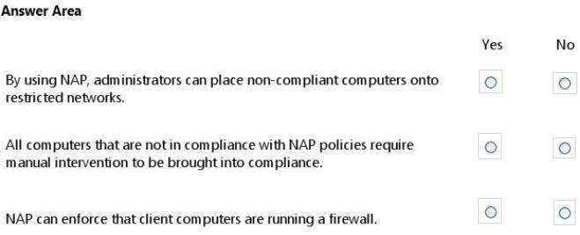

**Correct Answer:**

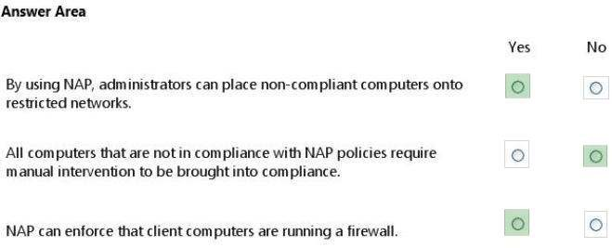

**Section: (none) Explanation**

**Explanation/Reference:**

**QUESTION 121**

Alice and Bob are exchanging messages with each other. Chuck modifies the messages sent between Alice and Bob as shown in the following image:

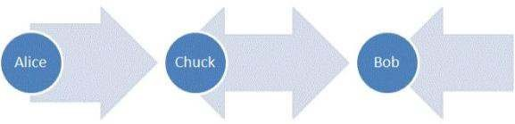

Use the drop-down menus to select the answer choice that completes each statement. Each

correct selection is worth one point.

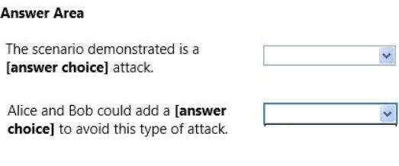

**Hot Area:**

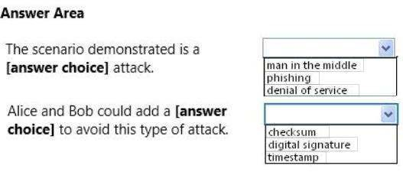

**Correct Answer:**

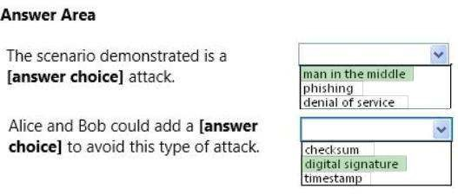

**Section: (none) Explanation**

**Explanation/Reference:** Explanation:

The usual way to prevent the man-in-the-middle attack is to use a public key cryptosystem

capable of providing digital signatures. For set up, the parties must know each others public keys

in advance. After the shared secret has been generated, the parties send digital signatures of it to

each other. The man-in-the-middle can attempt to forge these signatures, but fails because he cannot fake the signatures.

**QUESTION 122**

For each of the following statements, select Yes if the statement is true. Otherwise, select No.

Each correct selection is worth one point.

**Hot Area:**

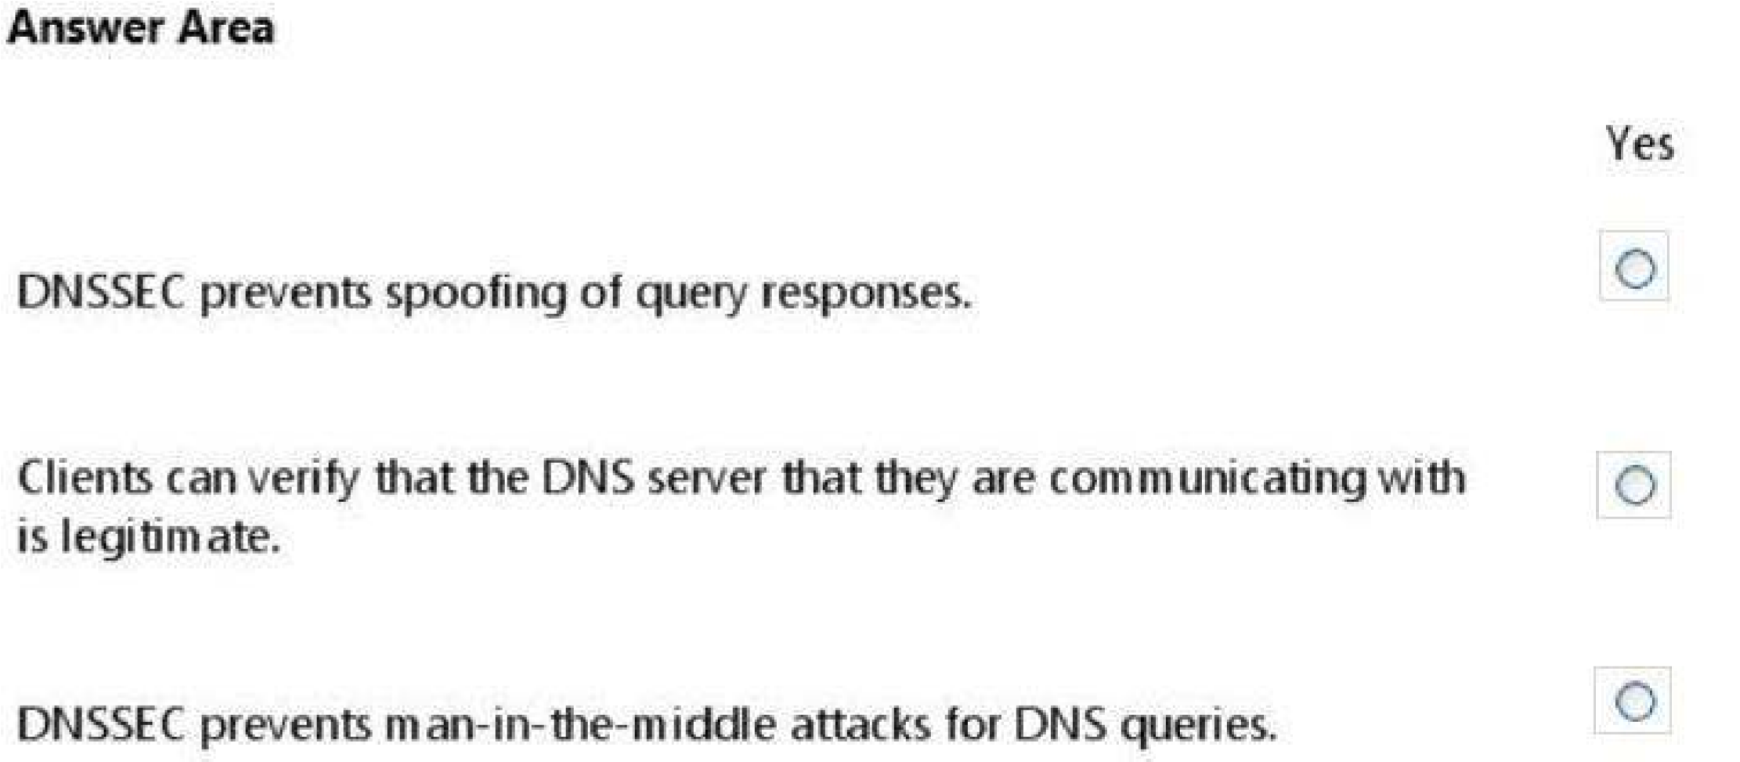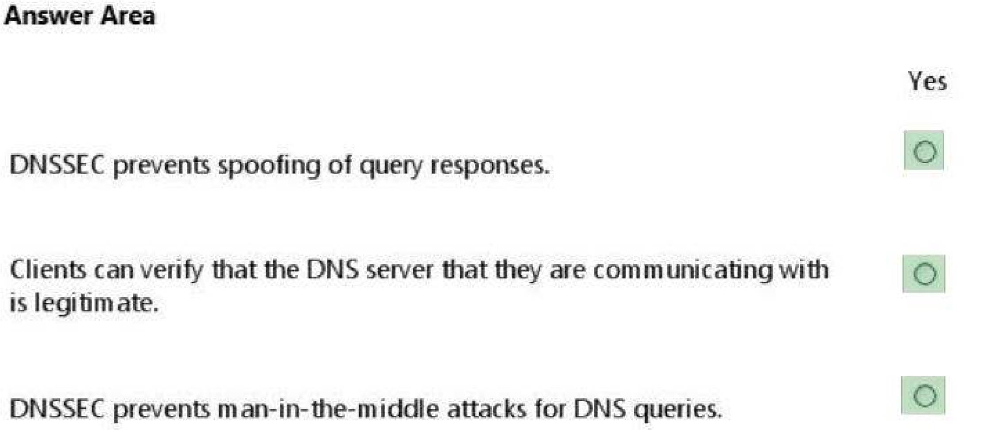**Correct Answer:**

**Section: (none) Explanation**

**Explanation/Reference:**

**QUESTION 123**

For each of the following statements, select Yes if the statement is true. Otherwise, select No.

Each correct selection is worth one point.

**Hot Area:**

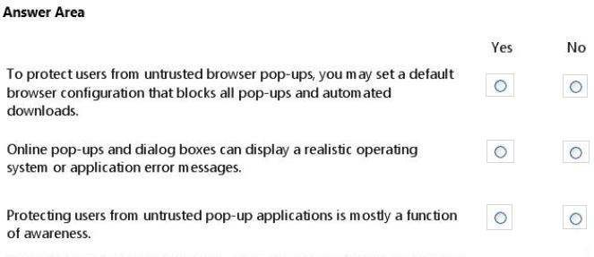

**Correct Answer:**

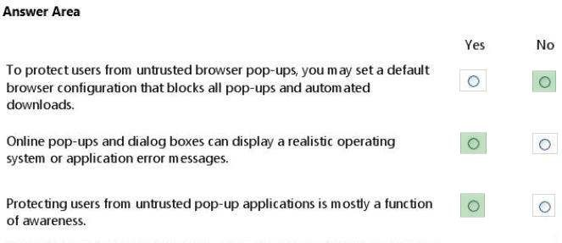

**Section: (none) Explanation Explanation/Reference:**

Practice Set A

Practice Exam for Security Fundamental Exam 98-367

**Que1: You have an application that uses IPsec to secure communication between an Internet client and a server on the internal network**

**To which network security service must the IPsec client connect?**

1. Radius
   1. VPN
2. SSH
3. SFTP

**Que2: The purpose of a RADIUS server is to provide**:

1. Multifactor authentication
2. Network encryption
3. Robust passwords
   1. External authentication.

**Que3:- The manager of a coffee shop hires you to securely set up WiFi in the shop. You want to allow only a certain list of computers to access the network. What should you use with an access point?**

1. Client bridge mode
2. Client isolation mode
3. MAC address filtering
4. Access control list

**Que4: Installing a system file checksum verification application on your servers is an example of ensuring**:

1. Confidentiality.
2. Availability.

c) Accessibility.

D) Integrity.

**Que5: Email spoofing:**

1. Obscures the true email sender.
2. Forwards email messages to all contacts.
3. Modifies email routing logs.
4. Copies email messages sent from a specific user.

**Que6: Microsoft Baseline Security Analyzer scans systems for**

1. Malware.
2. Missing firmware updates.
3. Missing security updates.
4. System errors.

**Que7: The reason for implementing Service Set IDentifier (SSID) masking is to:**

1. Hide a wireless network name from unknown computers.
2. Disable autologon.
3. Enforce a more secure password policy.
4. Hide a network share from unauthorized users

**Que8**: **You have a new computer and want to restrict other people from replacing the operating system.**

**Which action prevents a user from installing an alternate operating system by using physical media if the user has physical access to the computer?**

1. Password protecting the computer BIOS
2. Disabling removable devices and drives
3. Installing drive-level encryption
4. Removing the user from the administrators group

**Que9: You are using the Microsoft Edge browser to connect to a web server that hosts a test version of a web application. You receive the following message:**

**X There's a problem with this website's security certificate**

**This might mean that someone's trying to fool you or steal any info you send to the server. You should close this site immediately.**

**Go to my homepage instead**

**X Continue to this webpage (not recommended)**

Instructions: Use the drop-down menus to select the answer choice that completes each statement based on the information presented in the graphic.

**Note: Each correct selection is worth one point.**

1. This error message may be generated if the web server is configured to use a [answer choice] for TLS.
2. Purchasing a [answer choice] for the server and configuring the server to use it will most likely cause the issue to resolve itself.

Options are in Image Format which Is not avialiable..?

**Que10: You receive an email that appears to be from your help desk. The email tells you that your account has a problem. The email asks you to provide your account's usernaame and password in order to fix the problem. What is this an example of?**

1. Attack surface
2. Confidentiality
3. Demilitarized zone
4. Social engineering

**Que11: What are two reasons to implement VLANs? (Choose two.)**

1. Enable grouping of hosts regardless of physical location.
2. Manage traffic flow between the Internet and the network.
3. Separate hosts on the same network.

**D)**Create the most secure path between two hosts

**Que12: In a security context, the term "spoofing" means**:

1. Alteration.
   1. Deletion.
2. Impersonation.
3. Theft.

**Que13: What enables an employee to connect securely to a corporate network by using the Internet?**

1. Network Access Protection (NAP)
2. Remote Desktop Protocol (RDP)
3. Virtual Private Networking (VPN) D)Network Address Translation (NAT)

**Que14: Your anti-spam program is blocking emails from a particular sender. Your company needs to receive emails from this sender. What should you do?**

1. List the senders email address in DNS.
2. Add the email address to the whitelist.
3. Reconfigure the SMS Gateway.
4. Accept RSS feeds from their domain.

**Que15: You need to give a standard user permission to run a program as an administrator. How should you set up the program shortcut to accomplish this?**

1. In a different Compatibility Mode
2. By using a smart card
3. In a separate memory space
4. By utilizing RunAs

**Que16: This question requires that you evaluate the underlined text to determine if it is correct. Following the principle of least privilege and using the Microsoft Passport feature of Windows 10 can significantly mitigate the risks from malicious software.**

**Instructions: Review the underlined text. If it makes the statement correct, select No change is needed." If the statement is incorrect, select the answer choice that makes the statement correct.**

1. User Account Control
2. Credential Guard
3. Kerberos
4. No change is needed.

**Que17: You are trying to enable BitLocker on your father's computer.**

**What is the purpose of the Trusted Platform Module (TPM) when it is used by BitLocker**

1. To store the hashed data produced by BitLocker encryption
2. To store an encrypted file allocation table for the protected drive
3. To provide a co-processor that encrypts/decrypts data
4. To verify the integrity of the early boot components

**Que18: You are setting up file sharing for your project team.**

**Instructions: For each of the following statements. select Yes if the statement is true. Otherwise, select No. Note: Each correct selection is worth one point.**

1. NTFS permissions override Share permissions.
2. Share permissions can be used with FAT32 file systems.
3. To configure access to a Public folder, Microsoft
4. Recommends granting 'Change- Share permissions and "Modify" NTFS permissions to the Users group.

**Que19: Self-propagating malicious code is referred to as a:**

1. back door.
2. Trojan horse
3. worm.
4. Hoax

**Que20: Kerberos prevents:**

1. File corruption.
2. Spyware distribution.
3. Denial of Service attacks.

D) Replay attacks.

**Que21: You need to be able to track file access.**

**Which type of auditing should you implement?**

1. directory services
2. process tracking
3. logon events
4. object access

**Que22: This question requires that you evaluate the underlined text to determine if it is correct. Signing in using a complex password and a pass-phrase is an example of two-factor authentication. Instructions: Review the underlined text. If it makes the statement correct, select No change is needed." If the statement is incorrect, select the answer choice that makes the statement correct.**

1. retinal scan and voice recognition
2. smart card and a hardware token
3. No change is needed.
4. fingerprint scan and a password

**Que23**: **This question requires that you evaluate the underlined text to determine if it is correct. Malware is any kind of unwanted software that is installed without your consent.**

1. Worms are
2. No change is needed.
3. Viruses are
4. Trojans are

**Que24: The purpose of a RADIUS server is to provide:**

1. external authentication
2. network encryption.
3. multi-factor authentication
4. robust passwords

**Que25:** Which is the minimum requirement to create BitLocker-To-Go media on a dient computer**?**

1. Windows Vista Enterprise Edition
2. Windows 7 Enterprise Edition
3. Windows 10 Enterprise
4. Windows 8.1 Enterprise Edition

**Que26: Which two optional security measures provide additional multi-factor authentication for systems secured with BitLocker? (Choose two.)**

1. USB flash drive key
2. PIN

1. password
2. fingerprint

**Que28: You manage 50 Windows workstations in a computer lab. All workstations belong to the lab Active Directory domain. You need to implement several audit policies on each workstation in the shortest time possible.**

**What should you do?**

1. Turn on the Audit Policy on the domain controller.
2. Create a domain Group Policy.
3. Enable Audit object access.
4. Enable logging on each computer

**Que29: You are a network administrator. All computers run Internet Explorer 11. You need to protect users from phishing. What should you enforce?**

1. Cross-Site Scripting Filter
2. SmartScreen Filter
3. InPrivate Browsing
4. Antivirus protection

**Que30: You receive a phone call. The caller tells you that your Internet Service Provider account has a problem. The caller asks you to provide your account's user name and password in order to fix the problem. This is an example of**

1. social engineering.
2. password spoofing.
3. social networking.
4. best practices

**Que31: You are setting up a standard user account. Using the principle of least privilege, which task should you prevent the user from performing?**

1. Install software.
2. Access the Intranet
3. Send an email message.
4. Access public folders

**Que32: Setting a database to read-only is an example of applying**

1. confidentiality.
2. accessibility.
3. integrity.
4. availability.

**Que33: What should you do to prevent users from copying data to removable media?**

1. Disable copy and paste.
2. Lock the computer cases. C)Apply a group policy.

D) Store media in a locked room

**Que34: This question requires that you evaluate the underlined text to determine if it is correct. To keep third-party content providers from tracking your movements on the web, enable InPrivate**

**Browsing. Instructions: Review the underlined text. If it makes the statement correct, select No change is needed." if the statement is incorrect, select the answer choice that makes the statement correct**.

1. No change is needed.
2. Tracking Protection
3. SmartScreen Filter
4. Compatibility Mode

**Que34: Which type of malicious software is used to steal passwords typed into a computer?**

1. backdoor
2. EICAR
3. keylogger
4. ransomware

**Que35: You are configuring the network settings of computers in your school's computer lab. Instructions: For each of the following statements. select Yes if the statement is true. Otherwise, select No. Note: Each correct selection is worth one point**

1. Securing network communication through IPsec packet signing ensures data integrity while in transit.
2. IPsec packet encryption ensures that the data is invulnerable to eavesdropping attacks.
3. Most websites use IPsec to secure communications between their web servers and client web browsers

**Que36: Which technology examines packet header information to determine if network traffic is allowed to enter the internal network?**

1. dedicated firewall
2. BitLocker To Go
3. antivirus software
4. RADIUS server

**Que37: You have an application that uses IPsec to secure communications between an Internet client and a server on the internal network.**

**To which network security service must the IPsec client connect?**

* 1. SFTP

1. SSH
2. RADIUS
3. VPN

**Que38: The process of creating a barrier between domain members and non-domain members by using IPsec policies is referred to as:**

1. server isolation.
2. domain filtering.
3. server filtering.
4. domain isolation.

**Que39: Transmitting passwords in clear text leaves them vulnerable to interception by a /an:**

1. Kerberos client.
2. rogue DHCP server.
3. IPsec decoder. D)packet sniffer.

**Que40: A malicious user who intercepts and modifies communications is known as a:**

1. white hat hacker.
2. red hat hacker.
3. man-in-the-middle.
4. network sniffer.

**Que41: You want to prevent external users from acquiring information about your network. You should implement a:**

1. router.
2. firewall.
3. layer-3 switch.
4. proxy server.

**Que42: A process by which DNS zone data is obtained by an attacker is referred to as:**

1. Denial of Service.
2. spoofing.
3. phishing.
4. footprinting.

**Que43: Microsoft Baseline Security Analyzer scans systems for**

1. missing security updates.
2. missing firmware updates.
3. malware.
4. system errors.

**Que44: You need to grant a server administrator full privileges to a server in the domain by using the administrator's own domain user account. This account does not have administrative privileges to the domain. Which two objects should you use? (Choose two.)**

1. Local Security Policy
2. Local Group
3. Domain User
4. Local User

Practice Set B

Practice Exam for Security Fundamental Exam 98-367

QUESTION 1

Your company maintains a Web server that is accessible to the public. It should be placed in a/an:

1. primary DNS zone.
2. enterprise domain.
3. perimeter network.
4. Virtual Private Network (VPN). Correct Answer: C

Section: (none) Explanation Explanation/Reference:

QUESTION 2

1. network sniffer is software or hardware that:
2. captures and analyzes network communication.
3. records user activity and transmits it to the server.
4. protects workstations from intrustions.
5. catalogs network data to create a secure index. Correct Answer: A

Section: (none) Explanation Explanation/Reference:

QUESTION 3

Which enables an employee to connect securely to a corporate network by using the Internet?

1. Virtual Private Networking (VPN)
2. Remote Desktop Protocol (RDP)
3. Network Address Translation (NAT)
4. Network Access Protection (NAP) Correct Answer: A

Section: (none)

Explanation

Explanation/Reference:

QUESTION 4

You are trying to establish communications between a client computer and server. The server is not responding. You confirm that both the client and the server have network connectivity.

Which should you check next?

1. Data Execution Prevention
2. Microsoft Update
3. Active Directory Domains and Trusts
4. Windows Firewall

Correct Answer: D

Section: (none)

Explanation

Explanation/Reference:

QUESTION 5

You have an application that communicates by using plain text. You want to secure communcations between

the application and a server at the network layer. What should you implement?

1. IPSec
2. SFTP
3. TLS
4. SSH

Correct Answer: A

Section: (none)

Explanation

Explanation/Reference:

QUESTION 6

Which technology enables you to filter communications between a program and the Internet? A. Antivirus software

1. BitLocker To Go
2. RADIUS Server
3. Software firewall Correct Answer: D Section: (none) Explanation Explanation/Reference:

QUESTION 7

The primary purpose of Network Access Protection (NAP) is to prevent:

1. loss of data from client computers on a network.
2. non-compliant systems from connecting to a network.
3. unauthorized users from accessing a network.
4. users on a network from installing software. Correct Answer: B

Section: (none) Explanation Explanation/Reference:

QUESTION 8

1. malicious user who intercepts and modifies communications is known as a:
2. red hat hacker
3. man-in-the-middle
4. network sniffer.
5. white hate hacker. Correct Answer: B Section: (none) Explanation Explanation/Reference:

QUESTION 9

Which three file system objects can you specify the NTFS permissions for? (Choose three.) http://www.gratisexam.com/

1. Parents
2. Folders
3. Extensions
4. Files
5. Subfolders Correct Answer: BDE Section: (none) Explanation

Explanation/Reference: QUESTION 10

You need to prevent unauthorized users from reading a specific file on a protable computer if the portable

computer is stolen.

What should you implement?

1. Advanced Encryption Standard (AES)
2. Folder level permissions
3. File-level permissions
4. Distributed File System (DFS)
5. BitLocker

Correct Answer: E

Section: (none)

Explanation

Explanation/Reference:

QUESTION 11

Basic security questions used to reset a password are susceptible to:

1. social engineering.
2. hashing.
3. network sniffing.
4. Trojan horses. Correct Answer: A Section: (none)

Explanation

Explanation/Reference:

QUESTION 12

Which displays a user's level of access to a particular file or folder on the server?

1. The Resultant Set of Policy
2. The object's Effective Permission
3. The client computer's registry
4. The object's Advanced Attributes Correct Answer: B

Section: (none) Explanation Explanation/Reference: QUESTION 13

When conducting a security audit, the first step is to:

1. set up a virus quarantine area.
2. inventory the company's technology assets.
3. set up the system logs to audit security events.
4. install auditing software on your servers. Correct Answer: B

Section: (none) Explanation Explanation/Reference: QUESTION 14 Biometrics are used to:

1. study hacking behavior.
2. perform security audits.
3. authenticate users.
4. measure the attack surface. Correct Answer: C

Section: (none) Explanation Explanation/Reference:

QUESTION 15

A group of users has access to Folder A and all of its contents. You need to prevent some of the users from

accessing a subfolder inside Folder A.

1. Disable folder sharing
2. Change the owner
3. Block inheritance
4. Hide the folder Correct Answer: C Section: (none)

Explanation Explanation/Reference: QUESTION 16

How can you confirm whether a computer on your network is the target of a brute force attack?

1. Run the show all access command
2. Use antivirus software to scan the computer
3. Check your Windows folder for unsigned files
4. Check the security log for failed authentication attempts Correct Answer: D

Section: (none) Explanation Explanation/Reference: QUESTION 17

The default password length for a Windows Server domain controller is:

1. 0.
2. 5.
3. 7.
4. 14.

Correct Answer: C Section: (none) Explanation

Explanation/Reference:

QUESTION 18

Which is the minimum requirements to create BitLocker To Go media on a client computer?

1. Windows Vista Enterprise Edition
2. Windows 2000 Professional Service Pack 4
3. Windows 7 Enterprise Edition
4. Windows XP Professional Service Pack 3 Correct Answer: C

Section: (none) Explanation Explanation/Reference: QUESTION 19

Software designed to infiltrate or damage a computer without the user's consent is referred to as:

1. embedded.
2. freeware.
3. malware
4. unsigned. Correct Answer: C Section: (none) Explanation

Explanation/Reference: QUESTION 20

You need to be able to track file access. Which type of auditing should you implement?

1. Object access
2. Process tracking
3. Directory services
4. Logon events Correct Answer: A Section: (none) Explanation

Explanation/Reference:

QUESTION 21

Many Internet sites that you visit require a user name and password.

How should you secure these passwords?

1. Reuse the same password
2. Save them to a text file
3. Enable session caching
4. Save them to an encrypted file
5. Configure the browser to save passwords Correct Answer: D

Section: (none)

Explanation

Explanation/Reference:

QUESTION 22

The services or programs within a computer system that can be exploited by unauthorized users is referred to

as the:

1. default access.
2. hazard zone.
3. untrusted area.
4. attack surface. Correct Answer: D Section: (none)

Explanation Explanation/Reference:

QUESTION 23

You receive a phone call. The caller tells you that your Internet Service Provider account has a problem. The

caller asks you to provide you account's user name and password in order to fix the problem.

1. social engineering.
2. password spoofing.
3. best practices.

D. social networking.

Correct Answer: A

Section: (none)

Explanation

Explanation/Reference:

QUESTION 24

Setting a database to read only is an example of a

98-367 Security Fundamental Practice Questions Set C

**QUESTION 1**

Windows Firewall is a built-in. host-based, stateless firewall.

Select the correct answer if the underlined text does not make the statement correct. Select "No change is needed" if the underlined text makes the statement correct.

1. Stateful
2. Network layer
3. Packet filter
4. No change is needed

**Correct Answer:** A

**Explanation**

**Explanation/Reference:**

**QUESTION 2**

Bridging is a process of sending packets from source to destination on OSI layer 3.

Select the correct answer if the underlined text does not make the statement correct. Select "No change is needed" if the underlined text makes the statement correct.

1. Routing
2. Switching
3. Repeating
4. No change is needed.

**Correct Answer:** A

**Explanation**

**Explanation/Reference:**

**QUESTION 3**

The primary purpose of Network Access Protection (NAP) is to prevent:

1. Loss of data from client computers on a network.
2. Non-compliant systems from connecting to a network.
3. Users on a network from installing software.
4. Unauthorized users from accessing a network.

**Correct Answer:** B

**Explanation**

**Explanation/Reference:**

Explanation:

NAP enforces health policies by inspecting and assessing the health of client computers, restricting network access when client computers are noncompliant with health policy, and remediating noncompliant client computers to bring them into compliance with health policy before they are granted full network access. NAP enforces health policies on client computers that are attempting to connect to a network; NAP also provides ongoing health compliance enforcement while a client computer is connected to a network. Reference: http://technet.microsoft.com/en-us/library/cc754378(v=ws.10).aspx

**QUESTION 4**

You want to make your computer resistant to online hackers and malicious software.

What should you do?

1. Configure a forward proxy.
2. Install anti-virus software.
3. Enable spam filtering.
4. Turn on Windows Firewall.

**Correct Answer:** B

**Explanation**

**Explanation/Reference:**

**QUESTION 5**

Your company requires that users type a series of characters to access the wireless network.

The series of characters must meet the following requirements:

 Contains more than 15 characters

 Contains at least one letter

 Contains at least one number 

Contains at least one symbol

Which security technology meets these requirements?

1. WEP
2. WPA2 PSK
3. WPA2 Enterprise
4. MAC filtering

**Correct Answer:** B

**Explanation**

**Explanation/Reference:**

Explanation: Pre-shared key mode (PSK, also known as Personal mode) is designed for home and small office networks that don't require the complexity of an 802.1X authentication server. [9] Each wireless network device encrypts the network traffic using a 256 bit key. This key may be entered either as a string of 64 hexadecimal digits, or as a passphrase of 8 to 63 printable ASCII characters

**QUESTION 6**

Many Internet sites that you visit require a user name and password.

How should you secure these passwords?

1. Save them to a text file
2. Enable session caching
3. Configure the browser to save passwords
4. Save them to an encrypted file
5. Reuse the same password

**Correct Answer:** D

**Explanation**

**Explanation/Reference:**

**QUESTION 7**

Physically securing servers prevents:

1. Theft
2. Compromise of the certificate chain
3. Man-in-the middle attacks
4. Denial of Service attacks

**Correct Answer:** A

**Explanation**

**Explanation/Reference:**

**QUESTION 8**

To prevent users from copying data to removable media, you should:

1. Lock the computer cases
2. Apply a group policy
3. Disable copy and paste
4. Store media in a locked room

**Correct Answer:** B

**Explanation**

**Explanation/Reference:**

Reference: http://blogs.technet.com/b/askds/archive/2008/08/25/removable-storage-group- policy-andwindows-server-2008-and-windows-vista.aspx

**QUESTION 9**

You are an intern at Wide World Importers and help manage 1000 workstations. All the workstations are members of an Active Domain.

You need to push out an internal certificate to Internet Explorer on all workstations.

What is the quickest method to do this?

1. Local policy
2. Logon script
3. Windows Update
4. Group policy

**Correct Answer:** A

**Explanation**

**Explanation/Reference:**

**QUESTION 10**

In Internet Explorer 8, the InPrivate Browsing feature prevents:

1. Unauthorized private data input.
2. Unencrypted communication between the client computer and the server.
3. User credentials from being sent over the Internet.
4. Any session data from being stored on the computer.

**Correct Answer:** D

**Explanation**

**Explanation/Reference:**

Reference: http://windows.microsoft.com/en-us/windows/what-is-inprivate-browsing

**QUESTION 11**

The purpose of a digital certificate is to verify that a:

1. Public key belongs to a sender.
2. Computer is virus-free.
3. Private key belongs to a sender.
4. Digital document is complete.

**Correct Answer:** A

**Explanation**

**Explanation/Reference:**

Explanation:

In cryptography, a public key certificate (also known as a digital certificate or identity certificate) is an electronic document that uses a digital signature to bind a public key with an identity.

**QUESTION 12**

A mail system administrator scans for viruses in incoming emails to increase the speed of mail processing.

Select the correct answer if the underlined text does not make the statement correct. Select "No change is needed" if the underlined text makes the statement correct.

1. Decrease the chances of a virus getting to a client machine
2. Verify that the senders of the messages are legitimate
3. Ensure that all links in the messages are trustworthy
4. No change is needed.

**Correct Answer:** A

**Explanation**

**Explanation/Reference:**

**QUESTION 13**

You are volunteering at an organization that gets a brand new web server. To make the server more secure, you should add a second administrator account.

Select the correct answer if the underlined text does not make the statement correct. Select "No change is needed" if the underlined text makes the statement correct.

1. Disable unused services

B. Enable LM authenticationC. Enable NTLM authentication D. No change is needed.

**Correct Answer:** A

**Explanation**

**Explanation/Reference:**

**QUESTION 14**

Role separation improves server security by:

A. Enforcing principle of least privilege.

1. Installing applications on separate hard disks.
2. Physically separating high security servers from other servers.
3. Placing servers on separate VLANs.

**Correct Answer:** A

**Explanation**

**Explanation/Reference:**

**QUESTION 15**

The Windows Firewall protects computers from unauthorized network connections.

Select the correct answer if the underlined text does not make the statement correct. Select "No change is needed'' if the underlined text makes the statement correct.

1. Email viruses
2. Phishing scams
3. Unencrypted network access
4. No change is needed

**Correct Answer:** D

**Explanation**

**Explanation/Reference:**

**QUESTION 16**

Coho Winery wants to increase their web presence and hires you to set up a new web server. Coho already has servers for their business and would like to avoid purchasing a new one.

Which server is best to use as a web server, considering the security and performance concerns?

1. SQL Server
2. File Server
3. Domain Controller
4. Application Server

**Correct Answer:** C

**Explanation**

**Explanation/Reference:**

**QUESTION 17**

A user who receives a large number of emails selling prescription medicine is probably receiving pharming mail.

Select the correct answer if the underlined text does not make the statement correct. Select "No change is needed" if the underlined text makes the statement correct.

1. Malware
2. Spoofed mail
3. Spam
4. No change is needed.

**Correct Answer:** C

**Explanation**

**Explanation/Reference:**

**QUESTION 18**

The client computers on your network are stable and do not need any new features.

Which is a benefit of applying operating system updates to these clients?

1. Keep the software licensed
2. Keep the server ports available
3. Update the hardware firewall
4. Close existing vulnerabilities

**Correct Answer:** D

**Explanation**

**Explanation/Reference:**

**QUESTION 19**

Which password attack uses all possible alpha numeric combinations?

1. Social engineering
2. Brute force attack
3. Dictionary attack
4. Rainbow table attack

**Correct Answer:** C

**Explanation**

**Explanation/Reference:**

**QUESTION 20**

1. digitally signed e-mail message:
   1. Validates the recipient
   2. Validates the sender
   3. Is encrypted
   4. Is virus-free

**Correct Answer:** B

**Explanation**

**Explanation/Reference:**

Explanation:

By digitally signing a message, you apply your unique digital mark to the message. The digital signature includes your certificate and public key. This information proves to the recipient that you signed the contents of the message and not an imposter, and that the contents have not been altered in transit. Reference: http://office.microsoft.com/en-us/outlook-help/secure-messages-with-a-digital-signatureHP001230539.aspx

**QUESTION 21**

Passwords that contain recognizable words are vulnerable to a:

1. Denial of Service attack
2. Hashing attack
3. Dictionary attack
4. Replay attack

**Correct Answer:** C

**Explanation**

**Explanation/Reference:**

Explanation:

A dictionary attack is a method of breaking into a password-protected computer or server by systematically entering every word in a dictionary as a password. A dictionary attack can also be used in an attempt to find the key necessary to decrypt an encrypted message or document.

Dictionary attacks work because many computer users and businesses insist on using ordinary words as passwords. Dictionary attacks are rarely successful against systems that employ multiple-word phrases, and unsuccessful against systems that employ random combinations of uppercase and lowercase letters mixed up with numerals. Reference: http://searchsecurity.techtarget.com/definition/dictionary-attack

**QUESTION 22**

Account lockout policies are used to prevent which type of security attack?

1. Brute force attacks
2. Users sharing passwords
3. Social engineering
4. Passwords being reused immediately

**Correct Answer:** A

**Explanation**

**Explanation/Reference:**

**QUESTION 23**

What is the standard or basic collection of NTFS permissions?

1. Read and execute, read, write, full control, modify, list folder contents
2. Change permissions, read permissions, write permissions
3. Read attributes, list folder/read data, traverse folder/execute file
4. Create files/write data, create folders/append data, take ownership

**Correct Answer:** A

**Explanation**

**Explanation/Reference:**

Reference: http://technet.microsoft.com/en-us/library/bb727008.aspx

**QUESTION 24**

Which is the minimum requirement to create BitLocker-To-Go media on a client computer?

1. Windows XP Professional Service Pack 3
2. Windows Vista Enterprise Edition
3. Windows 7 Enterprise Edition
4. Windows 2000 Professional Service Pack 4

**Correct Answer:** A

**Explanation**

**Explanation/Reference:**

**QUESTION 25**

Which enables you to change the permissions on a folder?

1. Take ownership
2. Extended attributes
3. Auditing
4. Modify

**Correct Answer:** D

**Explanation**

**Explanation/Reference:**

**QUESTION 26**

A group of users has access to Folder A and all of its contents. You need to prevent some of the users from accessing a subfolder inside Folder A.

What should you do first?

1. Disable folder sharing
2. Hide the folder
3. Change the owner
4. Block inheritance

**Correct Answer:** A

**Explanation**

**Explanation/Reference:**

**QUESTION 27**

What are three examples of two-factor authentication? (Choose three.)

1. A fingerprint and a pattern
2. A password and a smart card
3. A username and a password
4. A password and a pin number
5. A pin number and a debit card

**Correct Answer:** ABE

**Explanation**

**Explanation/Reference:**

Explanation:

At minimum two-factor authentication requires two out of three regulatory-approved authentication variables such as:

 Something you know (like the PIN on your bank card or email password).  Something you have (the physical bank card or a authenticator token). 

Something you are (biometrics like your finger print or iris pattern).

**QUESTION 28**

You need to limit the programs that can run on client computers to a specific list. Which technology should you implement?

1. Windows Security Center
2. Security Accounts Manager
3. System Configuration Utility
4. AppLocker group policies

**Correct Answer:** A

**Explanation**

**Explanation/Reference:**

**QUESTION 29**

The purpose of User Account Control (UAC) is to:

1. Encrypt the user's account
2. Limit the privileges of software
3. Secure your data from corruption
4. Facilitate Internet filtering

**Correct Answer:** B

**Explanation**

**Explanation/Reference:**

Explanation:

User Account Control (UAC) is a technology and security infrastructure introduced with Microsoft's Windows machines. It aims to improve the security of Microsoft Windows by limiting application software to standard user privileges until an administrator authorizes an increase or elevation. In this way, only applications trusted by the user may receive administrative privileges, and malware should be kept from compromising the operating system.

**QUESTION 30**

What does implementing Windows Server Update Services (WSUS) allow a company to manage?

1. Shared private encryption key updates
2. Updates to Group Policy Objects
3. Active Directory server replication
4. Windows updates for workstations and servers

**Correct Answer:** D

**Explanation**

**Explanation/Reference:**

**QUESTION 31**

The purpose of Microsoft Baseline Security Analyzer is to:

1. List system vulnerabilities.
2. Apply all current patches to a server.
3. Set permissions to a default level.
4. Correct a company's security state.

**Correct Answer:** A

**Explanation**

**Explanation/Reference:**

**QUESTION 32**

The Graphic Design Institute hires you to help them set up a server for their 20-person team.

As a general practice of hardening the server, you start by performing which two tasks? (Choose two.)

1. Disable the guest account.
2. Rename the admin account.
3. Remove the account lockout policy.
4. Format partitions with FAT32.

**Correct Answer:** AB

**Explanation**

**Explanation/Reference:**

**QUESTION 33**

What are two attributes that an email message may contain that should cause a user to question whether the message is a phishing attempt? (Choose two.)

1. An image contained in the message
2. Spelling and grammar errors
3. Threats of losing service
4. Use of bold and italics

**Correct Answer:** BC

**Explanation**

**Explanation/Reference:**

Reference: http://www.microsoft.com/security/online-privacy/phishing-symptoms.aspx

**QUESTION 34**

Keeping a server updated:

1. Maximizes network efficiency
2. Fixes security holes
3. Speeds up folder access
4. Synchronizes the server

**Correct Answer:** B

**Explanation**

**Explanation/Reference:**

**QUESTION 35**

Before you deploy Network Access Protection (NAP), you must install:

1. Internet Information Server (IIS)
2. Network Policy Server (NPS)
3. Active Directory Federation Services
4. Windows Update Service

**Correct Answer:** B

**Explanation**

**Explanation/Reference:**

Reference: http://technet.microsoft.com/en-us/library/bb681008.aspx

**QUESTION 36**

What is a common method for password collection?

1. Email attachments
2. Back door intrusions

1. SQL Injection
2. Network sniffers

**Correct Answer:** D

**Explanation**

**Explanation/Reference:**

**QUESTION 37**

Which provides the highest level of security in a firewall?

1. Stateful inspection
2. Outbound packet filters
3. Stateless inspection
4. Inbound packet filters

**Correct Answer:** A

**Explanation**

**Explanation/Reference:**

**QUESTION 38**

The primary method of authentication in an SSL connection is passwords.

To answer, choose the option "No change is needed" if the underlined text is correct. If the underlined text is not correct, choose the correct answer.

1. No change is needed
2. Certificates
3. IPsec
4. Biometrics

**Correct Answer:** B

**Explanation**

**Explanation/Reference:**

Reference: https://www.geocerts.com/ssl/understanding_authentication

**QUESTION 39**

You are setting up Remote Desktop on your computer. Your computer is a member of a domain.

Your firewall configuration is shown in the following image:

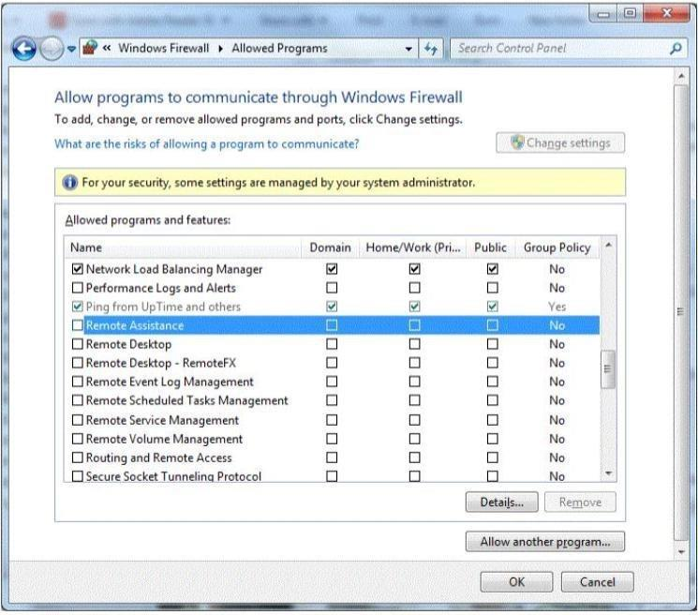

You need to allow Remote Desktop to be able to get through your firewall for users on your company's network.

Which settings should you enable?

1. Remote Assistance: Home/Work (Private)
2. Remote Desktop: Public
3. Remote Desktop: Home/Work (Private)
4. Remote Assistance: Domain

**Correct Answer:** A

**Explanation**

**Explanation/Reference:**

**QUESTION 40**

You are trying to connect to an FTP server on the Internet from a computer in a school lab. You cannot get a connection. You try on another computer with the same results. The computers in the lab are able to browse the Internet.

You are able to connect to this FTP server from home.

What could be blocking the connection to the server?

1. A layer-2 switch
2. A wireless access point
3. A firewall
4. A layer-2 hub

**Correct Answer:** C

**Explanation**

**Explanation/Reference:**

**QUESTION 41**

What does NAT do?

1. It encrypts and authenticates IP packets.
2. It provides caching and reduces network traffic.
3. It translates public IP addresses to private addresses and vice versa.
4. It analyzes incoming and outgoing traffic packets.

**Correct Answer:** C

**Explanation**

**Explanation/Reference:**

Reference: http://en.wikipedia.org/wiki/Network_address_translation

**QUESTION 42**

The default password length for a Windows Server domain controller is:

1. 0
2. 5
3. 7
4. 14

**Correct Answer:** C

**Explanation**

**Explanation/Reference:**

**QUESTION 43**

You create a web server for your school. When users visit your site, they get a certificate error that says your site is not trusted.

What should you do to fix this problem?

1. Install a certificate from a trusted Certificate Authority (CA).
2. Use a digital signature.
3. Generate a certificate request.
4. Enable Public Keys on your website.

**Correct Answer:** A

**Explanation**

**Explanation/Reference:**

**QUESTION 44**

What is an example of non-propagating malicious code?

1. A back door
2. A hoax
3. A Trojan horse
4. A worm

**Correct Answer:** A

**Explanation**

**Explanation/Reference:**

**QUESTION 45**

A brute force attack:

1. Uses response filtering
2. Tries all possible password variations
3. Uses the strongest possible algorithms
4. Targets all the ports

**Correct Answer:** B

**Explanation**

**Explanation/Reference:**

**QUESTION 46**

Humongous Insurance is an online healthcare insurance company. During an annual security audit a security firm tests the strength of the company's password policy and suggests that Humongous Insurance implement password history policy.

What is the likely reason that the security firm suggests this?

1. Past passwords were easily cracked by the brute force method.
2. Past passwords of users contained dictionary words.
3. Previous password breaches involved use of past passwords.
4. Past passwords lacked complexity and special characters.

**Correct Answer:** B

**Explanation**

**Explanation/Reference:**

**QUESTION 47**

The WPA2 PreShared Key (PSK) is created by using a passphrase (password) and salting it with the WPS PIN.

Select the correct answer if the underlined text does not make the statement correct. Select "No change is needed" if the underlined text makes the statement correct.

1. Service Set Identifier (SSID)
2. Admin password
3. WEP key
4. No change is needed

**Correct Answer:** A

**Explanation**

**Explanation/Reference:**

**QUESTION 48**

What are three major attack vectors that a social engineering hacker may use? (Choose three.)

1. Telephone
2. Reverse social engineering
3. Waste management
4. Honey pot systems
5. Firewall interface

**Correct Answer:** ABC

**Explanation**

**Explanation/Reference:**

**QUESTION 49**

Which two security settings can be controlled by using group policy? (Choose two.)

1. Password complexity
2. Access to the Run... command
3. Automatic file locking
4. Encrypted access from a smart phone

**Correct Answer:** AB

**Explanation**

**Explanation/Reference:**

Reference: http://technet.microsoft.com/en-us/library/cc875814.aspx

**QUESTION 50**

Cookies impact security by enabling: (Choose two.)

1. Storage of Web site passwords.
2. Higher security Web site protections.
3. Secure Sockets Layer (SSL).
4. Web sites to track browsing habits.

**Correct Answer:** AD

**Explanation**

**Explanation/Reference:**

Reference: http://en.wikipedia.org/wiki/HTTP_cookie

**QUESTION 51**

To keep third-party content providers from tracking your movements on the web, enable InPrivate Browsing.

Select the correct answer if the underlined text does not make the statement correct. Select "No change is needed'' if the underlined text makes the statement correct.

1. InPrivate Filtering
2. SmartScreen Filter
3. Compatibility Mode

D. No change is needed

**Correct Answer:** A

**Explanation**

**Explanation/Reference:**

**QUESTION 52**

Which enables access to all of the logged-in user's capabilities on a computer?

1. Java applets
2. ActiveX controls
3. Active Server Pages (ASP)
4. Microsoft Silverlight

**Correct Answer:** B

**Explanation**

**Explanation/Reference:**

**QUESTION 53**

You need to install a domain controller in a branch office. You also need to secure the information on the domain controller. You will be unable to physically secure the server.

Which should you implement?

1. Read-Only Domain Controller
2. Point-to-Point Tunneling Protocol (PPTP)
3. Layer 2 Tunneling Protocol (L2TP)
4. Server Core Domain Controller

**Correct Answer:** A

**Explanation**

**Explanation/Reference:**

Explanation:

A read-only domain controller (RODC) is a new type of domain controller in the Windows Server® 2008 operating system. With an RODC, organizations can easily deploy a domain controller in locations where physical security cannot be guaranteed. An RODC hosts read-only partitions of the Active Directory® Domain Services (AD DS) database. Explanation: http://technet.microsoft.com/en-us/library/cc732801 (v=ws.10).aspx

**QUESTION 54**

E-mail spoofing:

1. Forwards e-mail messages to all contacts
2. Copies e-mail messages sent from a specific user
3. Obscures the true e-mail sender
4. Modifies e-mail routing logs

**Correct Answer:** C

**Explanation**

**Explanation/Reference:**

Reference: http://www.microsoft.com/mscorp/safety/technologies/senderid/technology.mspx

**QUESTION 55**

What is the primary advantage of using Active Directory Integrated Zones?

1. Zone encryption
2. Password protection
3. Non-repudiation
4. Secure replication

**Correct Answer:** D

**Explanation**

**Explanation/Reference:**

Reference: http://books.google.com/books?id=CXy-2LBZCVgC&pg=PA201&dq= %22Active+Directory +Integrated+Zones%22,+Secure+replication&hl=en&sa=X&ei=9s92U- v1KI-zyASjzILIDg&ved=0CE0Q6AEwAQ#v=onepage&q=%22Active%20Directory %20Integrated%20Zones% 22%2C%20Secure%20replication&f=false

**QUESTION 56**

Which two are included in an enterprise antivirus program? (Choose two.)

1. Attack surface scanning
2. On-demand scanning
3. Packet scanning
4. Scheduled scanning

**Correct Answer:** BD

**Explanation**

**Explanation/Reference:**

**QUESTION 57**

Phishing is an attempt to:

1. Obtain information by posing as a trustworthy entity.
2. Limit access to e-mail systems by authorized users.
3. Steal data through the use of network intrusion.
4. Corrupt e-mail databases through the use of viruses.

**Correct Answer:** A

**Explanation**

**Explanation/Reference:**

Explanation:

Phishing is the act of attempting to acquire sensitive information such as usernames, passwords, and credit card details (and sometimes, indirectly, money) by masquerading as a trustworthy entity in an electronic communication.

**QUESTION 58**

Humongous Insurance needs to set up a domain controller in a branch office. Unfortunately, the server cannot be sufficiently secured from access by employees in that office, so the company is installing a Primary Domain Controller.

Select the correct answer if the underlined text does not make the statement correct. Select "No change is needed" if the underlined text makes the statement correct.

1. Read-Only Domain Controller
2. Backup Domain Controller
3. Active Directory Server

D. No change is needed.

**Correct Answer:** A

**Explanation**

**Explanation/Reference:**

**QUESTION 59**

Where should you lock up the backup tapes for your servers?

1. The server room
2. A filing cabinet
3. The tape library
4. An offsite fire safe

**Correct Answer:** D

**Explanation**

**Explanation/Reference:**

Explanation:

Backup tapes should be stored off site, preferably in a fire safe, so that the data is available should a fire, flood, or other disaster affect the location were the servers are.

**QUESTION 60**

Which is a special folder permission?

1. Read
2. Modify
3. Write
4. Delete

**Correct Answer:** D

**Explanation**

**Explanation/Reference:**

Reference: http://support.microsoft.com/kb/308419

**QUESTION 61**

When conducting a security audit the first step is to:

1. Inventory the company's technology assets
2. Install auditing software on your servers
3. Set up the system logs to audit security events
4. Set up a virus quarantine area

**Correct Answer:** A